

The Somerset Tour
From Sunday 7th September to Thursday 11th September 2025

We will be based at the Homewood Hotel, 6 miles south of Bath, for 4 nights from Sunday 7th September 2025. This is a country hotel with a large estate and has a swimming pool and spa. From the hotel, we will tour attractive villages, the Mendip hills, and the Somerset levels. Somerset is characterised by a succession of rolling hills interspersed with low-lying flood plains, and contains four Areas of Outstanding Natural Beauty. It is essentially a rural county with two great traditions of agriculture – dairy, and apple and fruit growing. Taunton is the County town.
The Elegant and Marvellous rooms, which are the most numerous, are spacious. The Suites priced at £3,890 are very spacious and have their own hot tubs. All rooms include access to the hotel spa. There are two small Mews Cosy Luxe Rooms available which would suit single occupancy.

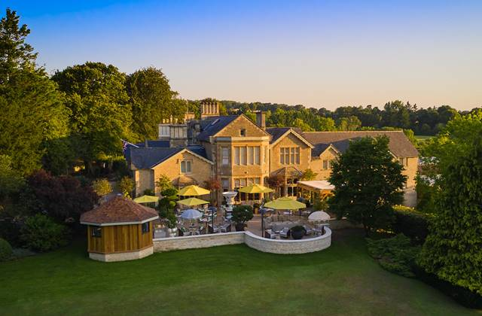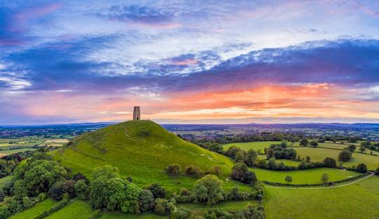
Homewood Hotel Glastonbury Tor

Day 1 - We will drive north and west making a foray into Wiltshire and visiting Bradford upon Avon, sometimes called a mini-Bath, Lacock and Castle Combe. Both these latter villages have been used as period film locations. Lacock is mostly owned by the National Trust.
Day 2 - Driving south-west from the hotel, we will visit Wells, England’s smallest city and a medieval gem. A visit is planned to the thirteenth century Cathedral and the Bishop’s Palace – home to the Bishops of Bath and Wells for over 800 years. From Wells we will drive to the Somerset levels visiting Glastonbury Tor and mythical Avalon. Then we will head north and drive through the mighty chasm of Cheddar Gorge and the Mendips back to the hotel.
Day 3 – Heading south again, this time to the southernmost part of Somerset via the market town of Shepton Mallet and the attractive town of Castle Cary. Our destination will be the Fleet Air Arm Museum just north of Yeovil. An exclusive group tour of the Museum is planned. The Museum is the largest naval aviation museum in Europe. A highlight is the Aircraft Carrier Experience where helicopter and fighter jets taking off and landing can be experienced.
Tour of Somerset
Sunday 7th September to Thursday 11th September 2025

Please email rslwilks@gmail.com and scan/send this form to Steve Wilks, Maryland, Wilverley Road, Brockenhurst SO42 7SP with a copy to the Club’s Treasurer, Philip Hall: pah.rr@btinternet.com.

I would like to join this tour of 4 nights starting on Sunday 7th September 2025 and finishing on Thursday 11th September 2025. The price of the tour will be from £2,530 per couple depending upon the category of room chosen. The prices include a reception and wine with dinner. The Homewood Hotel is demanding a large deposit. Therefore, the Club must match this and a deposit of £1,000 is required. Please note that deposits are non-refundable in the event of cancellation unless a substitute is found, or hotel credits are obtained.

Full names of driver and passengers: …………………….……………………………………………………..……..

Address: ………………………………………………………………………………………..………………………

E-mail address: ……………………………………………………………………………………......

Number of mobile phone/(s) on tour……………….……………………………………………………

Dietary requirements, if any................................................................................................................

Please indicate your order of 2 preferences (eg 1,2) for your preferred category of room in the boxes below and send a deposit of £1,000..

Elegant (£2,530) ……. Marvellous (£2,725) ……. Spa Suites (£3,625) …. Luxe Hot Tub Suite (£3,625) ……

Type of bed: Double or twin …………………………….

Car: Model............................................... Chassis No................ Reg No................... Year................

Body style/type.........................................................Colour(s)......................................

As a participant in this event and in consideration of the right and privilege to enter and participate in this event and intending to be legally bound, I agree to release The 20-Ghost Club Limited and all committee members and its representatives from any and all liability and injuries, damage or loss or consequential loss arising from my entry and participation in the event. I also agree that information about the participating car, the names of the driver and passengers, including photographs taken during the event and tour, will be included in the Members’ only section of the Club’s website as a record of Club activities and may be published in the Club’s journal, News & Record, unless I inform the Editor by e-mail that I do not wish such information and/or photographs to appear. I confirm that I will have public liability insurance cover in place should I be accepted for this tour/event. I further confirm that I have read and understand the Club’s rules relating to tours (deposits and cancellations) contained in paragraphs 10 to 13 of the Club Rules contained in the Members’ section of the Club’s website under Statutory & Legal.

Signed…………………………………….. Dated ……..................................................

Please pay as follows :-

Bank – Lloyds;
Sort code: 30-96-35
Branch: CARFAX OXFORD
BIC: LOYDGB21023
IBAN: GB69 LOYD 3096 3500 0668 03
Account name: The 20-Ghost Club Limited
Account no: 00066803

Note: The hotels and itinerary shown above are based on current plans. Once applications and deposits have been received, these arrangements will be progressed and confirmed although there may be unavoidable changes to hotels and other plans.

