**20-Ghost Club Trophies**

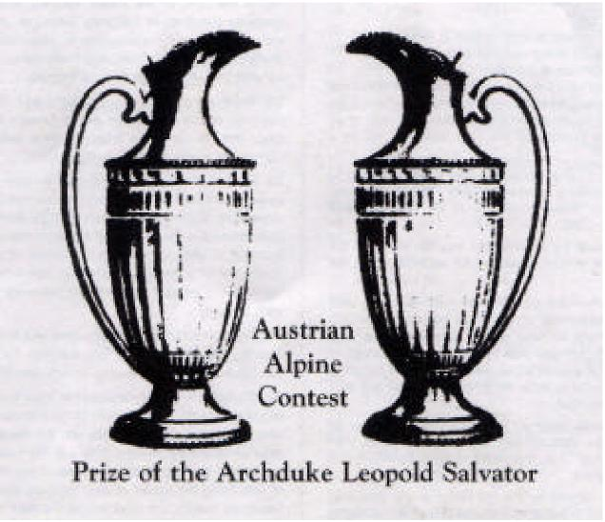

1. Alpine Trophy. One of two cut glass decanters originally given by the Archduke Leopold Salvator of Austria as one of the prizes in the Austrian Alpine Trials in 1913. It was won by C.C. Friese and subsequently presented to the Club by Rolls Royce Ltd. Awarded to the owner of the car which achieves maximum marks between 1 December and the following 30 November for mileage relative to age according to the formula below:-

1. The car must be in the possession of the same owner throughout the period in which mileage occurred, but need not be driven by him or her in toto.
2. The prize is for the car. Owners of more than one car may enter them separately, but may not aggregate mileage for the trophy.
3. One mark is awarded for each mile covered during the period, whether covered on business or pleasure, at home or abroad.
4. Mileage is multiplied by the age of the car on 31 December of the year in which each competition commences.

2. Woodmansee Trophy. A pair of book ends in solid brass, the very last of the original 'Silver Lady' mascots cast from the actual sculptor's moulds by Charles and Jo Sykes in 1939. Surplus to the final order, they were subsequently offered by Jo to Rolls-Royce in the early 1950s and accepted and paid for by them. In 1957, at the Concours d'Elegance organised by the 20-Ghost Club as part of the Silver Ghost Jubilee Rally at Buxton, these mascots were donated by Rolls-Royce as first prize, which was won by Webster Woodmansee of Milwaukee, USA, with his 1922 Springfield Silver Ghost Brewster Tourer (62UG) and in 1989 donated back to the Club on its fortieth anniversary. Awarded annually to the owner of the Silver Ghost which travels the greatest distance between 1 December and the following 30 November, or if a Silver Ghost wins the Alpine Trophy, then to the next highest Silver Ghost mileage.

3. Harding Rolls Trophy. Originally won by Hon Charles S. Rolls and presented to the Club by Lt Col J.C. Harding Rolls in 1962. Awarded to the member who in the opinion of the Committee has produced the most notable performance with an eligible Rolls Royce motor car.

4. Stanley Sears Trophy. Presented by Stanley Sears in 1962 when he was Club President. Awarded to the member who in the opinion of the Committee has contributed most by individual meritorious service to the Club.

5. Dymock Maunsell Trophy. Presented by Lt Cdr L.C. Dymock-Maunsell R.N. in 1962. Awarded to the best driver at the annual driving tests.

6. Fred & Joan Watson Trophy. Presented by Fred & Joan Watson in 1981. Awarded to the best large horsepower car (Silver Ghosts & Phantoms) at the Club Annual Concours. (Not awarded to the same car in two successive years).

1. Messervy Trophy. A Silver Salver presented in 1954 by Roney Messervy who in the early years built up a happy liaison between the Club and Rolls-Royce Ltd. He worked for virtually all his life with Rolls-Royce, ending as Service Manager at Hythe Road. Awarded to the best small horsepower car at the Club Annual Concours. (Not awarded to the same car in two successive years).
2. Fergusson-Wood Trophy. Presented by Harry Fergusson-Wood and is awarded to members under 35 years of age or members who have joined the Club within the previous four years, who in the opinion of the Executive Committee have taken part in, or been involved in, the most Club activities in the previous year.
3. F-W Photographic Trophy. Presented by Harry Fergusson-Wood in 1973 and awarded for the best photograph of a Club car or cars (preferably at a Club event), taken recently by a member and published in the Club magazine. Entries may be in colour or black and white on any medium.
4. Phoenix Trophy. Presented by Capt R.B. Honnywill R.N. and is awarded to the member who in the opinion of the Committee has carried out the most interesting and thorough reconstruction or restoration on an old chassis, or, if no eligible contenders, a member who has personally carried out a major engine rebuild or bodywork refurbishment on a previously restored car which has not been in recent use. This trophy is not awarded annually of necessity but only when there is a worthy recipient.
5. Ladies Trophy. Presented by Bess and Susan Taylor in 1989, this cut glass decanter is awarded annually for the car judged to be the most attractive in the opinion of all the ladies present at the Club Annual Concours.
6. The Small Horsepower Trophy. A Rolls-Royce mascot and piston presented to the Club by Clive Carter in 1997. The trophy was given to Clive’s father by Geoff Blowers, for many years head of the service department of Weybridge Automobiles, who had many friends at the Rolls-Royce service depot in Hythe Road. Awarded annually to the owner of the small horsepower car which travels the greatest distance between 1 December and the following 30 November, or, if a small horsepower car wins the Alpine Trophy, then to the car covering the next greatest distance.
7. The Harry Watson Trophy. Presented by Patricia Watson in 2000, in memory of her husband the late Harry Watson MBE. Awarded for Engineering Accomplishment to the member who in the opinion of the Committee made an outstanding engineering or technical contribution in the year. This trophy is not awarded annually but only when there is a worthy recipient.
8. The Brian Wootton Aviator Mascot. Presented by Jo Wootton in 2003 in memory of her husband the late Brian Wootton who was renowned for his care for other members. Awarded to the person who, in the judgement of the Committee, offered the most assistance to other members on tours in the year.