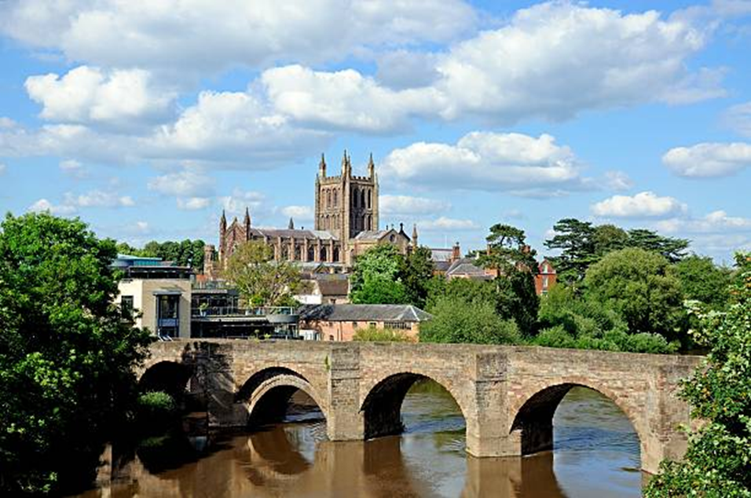

**Tour in Herefordshire with the Irish Georgian Society**

**Friday, 19th to Monday, 22nd May 2023**

Once again the 20-Ghost Club is privileged to have been invited by the London Chapter of the Irish Georgian Society to join them with our cars on a tour to visit historic country houses. This year we shall be visiting the beautiful county of Herefordshire, where architect and former chairman of the IGS London Chapter, Nicholas Thompson resides and has been making arrangements for the tour.

The group will be based in Hereford at the Green Dragon Hotel, Broad Street, built on the site of one of the oldest hostelries in the land, originally built to accommodate pilgrims visiting the shrines of St Ethelbert and St Thomas at Hereford Cathedral. It later became popular as a coaching inn and the centre of fashionable life in the city and for those attending Hereford Races. The present hotel has recently been fully refurbished and provides comfortable modern accommodation. We have not before based one of our tours in a cathedral city; and we shall be making the most of this opportunity, visiting the Cathedral on Friday afternoon, where we shall also be able to see the famous medieval chained library and the Mappa Mundi, the largest surviving medieval map of the world. We shall also be able to enjoy the music of the Cathedral for those who wish to by attending Choral Evensong. The motor cars of the 20-Ghost Club will be parked in the courtyard of the Bishop’s Palace close by the hotel and where each day will begin and end, the 20-Ghost Club members providing transport for IGS members in their cars. There will be no need for further driving on the day of arrival or for night-driving during the tour. Mileage each day should not exceed 70 miles in total.

Saturday, Sunday and Monday will be spent touring the picturesque surrounding countryside, where there will be opportunities to visit a variety of significant country houses, some of which are not normally open to the public. As arrangements stand, the tour will include Brampton Bryan Hall, Shobdon Church, Moccas Court, Brinsop Court, Hampton Court Castle and Eastnor Castle, with an excursion into Monmouthshire to visit The Hendre, ancestral estate of the Rolls family and childhood home of Charles Rolls, the motoring and aviation pioneer and co-founder of Rolls-Royce. Other houses will be included.

The tour will commence in Hereford at 3 o’clock on Friday, 19th May and end at the hotel at 5 o’clock on Monday 22nd May. The cost of the tour to 20-GC members will be £795.00 per person sharing in a double or twin-bedded room. Spaces for those requiring single rooms will be available at £955.00. These prices include the cost of visits, dinner and overnight accommodation on Friday 19th May, breakfast, lunch, dinner and overnight accommodation on Saturday 20th and Sunday 21st May, and breakfast and lunch on Monday 22nd May. In the event of the tour being oversubscribed, the availability or otherwise of the type and extent of accommodation requested will need to be to be taken into account, as well as other factors. In the event of insufficient space being available in the cars of the 20-Ghost Club at any time, supplementary transport will be provided by the IGS. Accommodation for additional nights at the hotel before or after the tour should be available but will be subject to separate arrangement and additional cost to be agreed.

Those who wish to come on the tour should complete the application form and return this by 17 March to Jimmy (F.A.B) Valentine at the address shown, together with a cheque for the appropriate amount. Please await confirmation that your application has been accepted, together with further details of the tour, before making other arrangements.

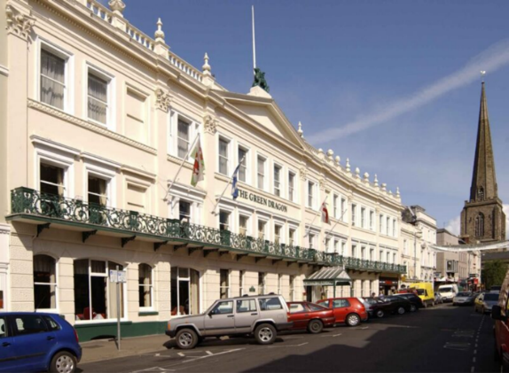 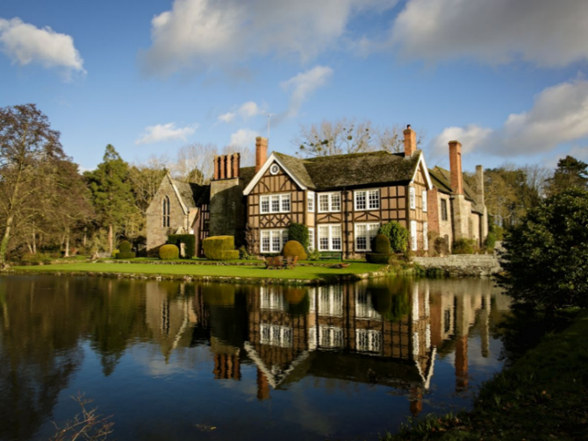

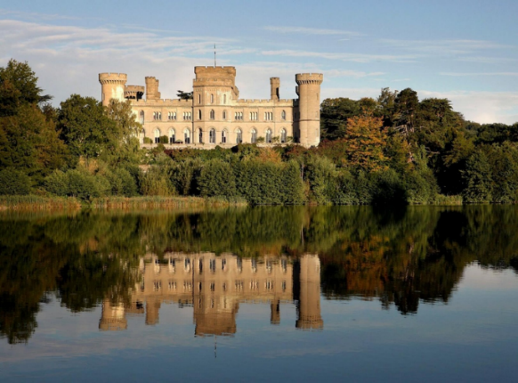 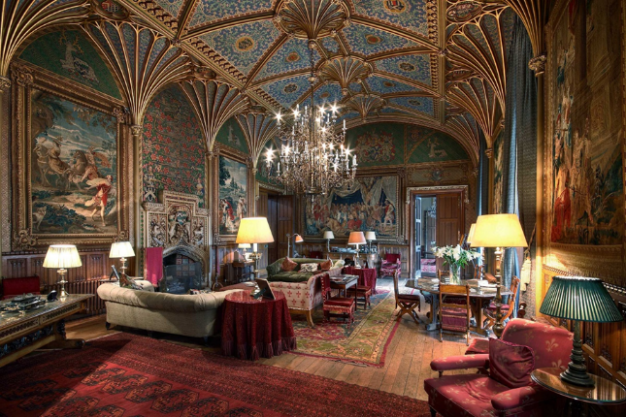

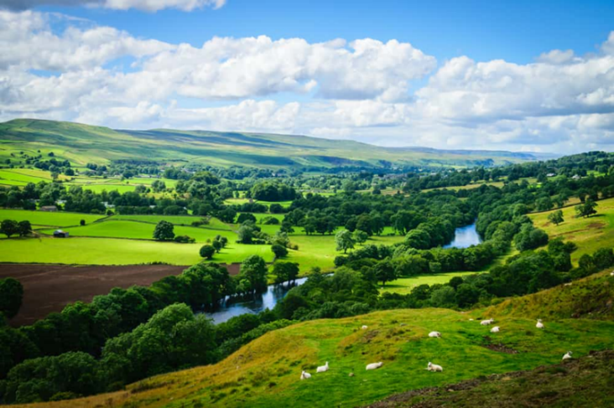 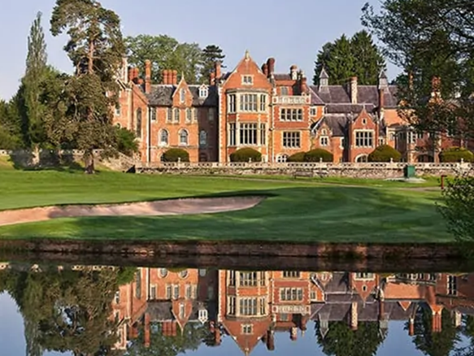

Green Dragon Hotel, Brinsop Court, Eastnor Castle and interior, the Wye Valley, The Hendre

**Tour in Herefordshire with the Irish Georgian Society**

**Friday, 19th to Monday, 22nd May 2023**

I wish to reserve ______ places at £795.00 per person for two sharing in a double / twin-bedded room [please circle or highlight as required]

I wish to reserve ______place(s) at £955.00 per person in a room for single occupation

Names(s)

…………………………………………………………………………………………………………..

…………………………………………………………………………………………………………..

Address:

…………………………………………………………………………………………………………..

…………………………………………………………………………………………………………..

……………………………………………………………… Postcode)………………………………

Telephone:

…………………………………………… (home landline)…………………….…………..(mobile)

Email address (legibly please and using capital letters):

……………………………………………………………………………………………………………

Name of Navigator……………………………………………………………………………………..

Car Model………………………………………………………Year …………………………………

Registration No ………………………………………………..Chassis No ………………………..

Number of comfortable seats for IGS members…………………………………………………….

Dietary requirements, if any:

……………………………………………………………………………………………………………

I/we enclose cheque(s) to **Irish Georgian Society London** in the sum of £…………………..

[Signed]

……………………………………………………………………………………………………………

[Delete below if not applicable]

I/we should be interested in staying an additional night in the hotel before and/or after the tour by separate arrangement and at additional cost. Please advise further about this if our application is successful.

Applicants should complete this form and send it with their cheque(s) and a self-addressed envelope by 17 March to

**F.A.B. Valentine, 16 Upper Astrop Road, King’s Sutton, Banbury, OX17 3QL**

Booking queries by email to [f.valentine215@btinternet.com](mailto:f.valentine215@btinternet.com) or by phone to 01295 811 215