**The Centenary plus 10!**

A re-enactment of the 1911 Top Gear run from London to Edinburgh

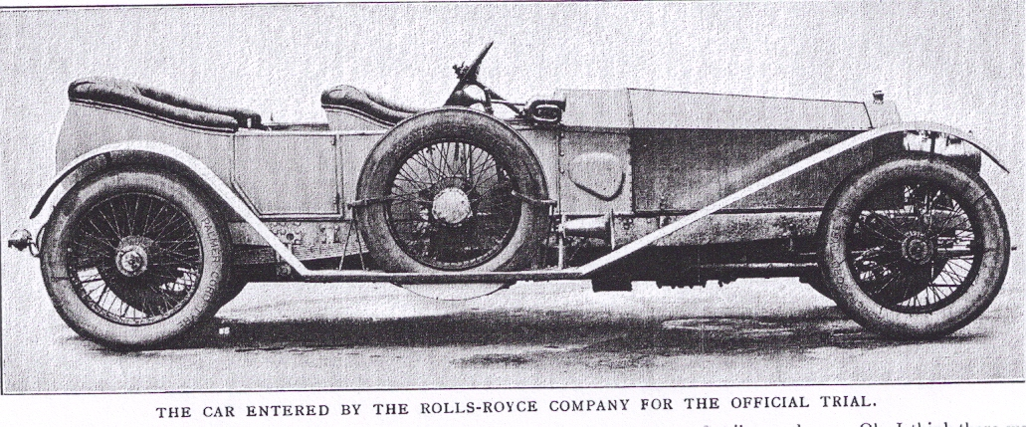

**Saturday 4th to Tuesday 7th September 2021**

The 1911 RAC observed London to Edinburgh Trial, was a major test for Edwardian cars. The point was to demonstrate that the performance, flexibility and economy of the Silver Ghost was superior when compared to its archrival the Napier. At the same time, it broadened the appeal of the car to a younger and sportier clientele, without disturbing the “Duchess clientele”, at that time the mainstay of Rolls Royce production.

The RAC observers ensured that only top gear was used, including pulling away from a standstill, quite an achievement 100 years ago before motorways and metalled roads.

The car was then driven back to London and achieved a top speed of 78mph at Brooklands with 4 people aboard to prove that the car was using a normal back axle ratio.

The 20-Ghost Club celebrated the Centenary with a re-enactment in 2011, when 8 of the 14 cars participating managed to drive from London to Edinburgh in modern traffic conditions only using top gear. Unfortunately, no one managed to achieve the extraordinary 24 mpg achieved in 1911, admittedly at an average of 19.6 mph, conveniently just under the countrywide speed limit of 20mph.

This 110th anniversary re-enactment has been designed to coincide with the new start date for the tour of Scotland and aims to slide quite seamlessly one into the other. If however you only wish to take part in this trial, we would, nevertheless give you a warm welcome.

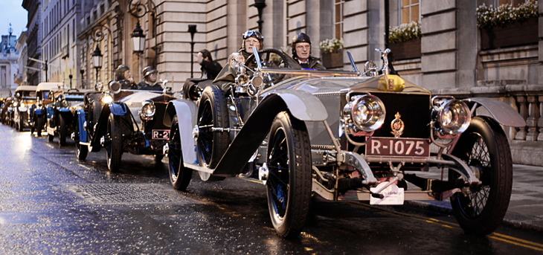

We will meet at the Royal Automobile Club on Saturday 4th Sept for a champagne reception in the Segrave Room followed by dinner in the Great Gallery and overnight accommodation will be provided. It should be possible to arrange accommodation at the Club for the Friday should you wish to settle in before the event. Cars will be parked in St James’s Square overnight with security arranged by the RAC.

As with the centenary re-enactment, all participating Silver Ghosts will be fitted with machined inserts for the gearbox gate to prevent the use of any gear other than top and reverse. To ensure fair play, the blocks will be held in place with locking wire and a Rolls-Royce stamped lead seal.

We will leave London early on the Sunday morning to avoid difficult traffic conditions and follow the Great North Rd out of London heading for Rudding Park, near Harrogate for our first night. From there on Monday, we continue on to Edinburgh (still in top gear!) to stay for a night aboard the luxury Hotel ship Fingal moored next to the Royal Yacht Britannia.

On this our final evening, we have arranged a private tour and celebratory dinner aboard the Royal Yacht Britannia.

**Due to a limit on bedrooms aboard Fingal, (a floating luxury hotel moored next to Britannia) we may have to arrange alternative accommodation ashore (at reduced cost). The 23 rooms on Fingal will be reserved on a first come first served basis.**

For those wishing to arrive in London early, accommodation at the RAC club for the Friday night is also available. **Please tick on the booking form for further details**.

There is one luxury suite available on Fingal at (significant!) extra cost, should anyone wish to book it. **Please tick on the booking form if you are interested.**

Arrangements for the 1st Scottish Tour have been changed to ensure a more relaxed start to this tour with an extra night at the Cally Palace Hotel at the start of the tour and Ken will be in touch with all participants to update them on the changes and costs. Those booked on the 1st Scottish tour will travel the 110 miles to the Cally Palace in Gatehouse of Fleet at their leisure on Tuesday, to be there by late afternoon. Others may wish to spend another night on Fingal. This extra night is not included in the tour price.

Contact Ken if you are interested in joining the Scottish Tour and have not yet registered, as places on the Scottish Tour may become available.

Please indicate your preferences on the booking form.

The inclusive London to Edinburgh tour cost will be:

Single occupancy £1400 (Fingal only has 23 double rooms so there will be a discount should there not be enough rooms available and some participants have to stay in a hotel ashore)

Double occupancy £2250

Please send your completed booking form with a deposit of £1000 double or £500 single to Jo Naismith as soon as possible.

Technical support and backup will be provided on the trial

**Jo Naismith, Guildables, Guildables Lane, Crockham Hill, Kent TN8 6QU;** [**Tel:07966264290**](Tel:07966264290)**; email: jo.naismith@yahoo.com**

Members’ and Guests’ Names……..………………………………………………………………………………………

…………………………………………………………………………………………………………………………………………….

Address ……………………………………………………………………………………………………………………

……………………………………………………………………………………………………………………………..

E-mail address……………………………………………………………………………………………………………..

Please reserve ……….................................places on the “Centenary plus 10” Top Gear Trial

**I/we are interested in upgrading to the Penthouse Suite on Fingal at extra cost YES/NO**

**I/We wish to stay on Fingal for an extra night (Tuesday) at extra cost YES/NO**

I enclose a cheque for £………….......... made payable to The 20-Ghost Club Limited.

OR I have transferred £…………........... to the Club’s bank account.

Car details: Year ………………………Model …………………….…. Chassis No……………………………..

Body type …………………………………………….. Coachbuilder …………………………………………………

|  |
| --- |
| For Sterling:  Bank – Lloyds, Carfax, Oxford  Account name: The 20-Ghost Club Ltd  Sort code: 30-96-35  Account No: 00066803  IBAN: GB69 LOYD 3096 3500 0668 03  BIC: LOYDGB21023 |