
The Baltic Region in Summer
A 22-night tour of Finland, Sweden, Latvia & Estonia
Wednesday 2nd July to Thursday 24th July 2025

The weather in July is perfect for a car tour of the Baltic Region. The days are long and warm. Country roads are interspersed with places of great interest – the grand city of Stockholm, once the capital of a major empire; the well preserved, picturesque, medieval town of Tallinn in Estonia; Riga in Latvia with its Art Nouveau architecture; and Finland with its natural landscape and fine food based on local products, not least fish from the thousands of lakes and the Baltic Sea.

The three-week tour will begin and end in Helsinki. We will visit four countries, using country roads and passenger/car ferries to cross the Baltic Sea from Turku to Stockholm (overnight), Stockholm to Riga (overnight) and Tallinn to Helsinki (short morning crossing). For those bringing cars from the UK, Transfennica, a reliable company offering return Ro-Ro services, will convey the cars by ship between the UK and Finland while participants fly to and from Helsinki. If they wish, Continental members will be able to travel on regular passenger ferries, with their cars, from a southern Baltic Sea port either in Germany or Poland to Helsinki. As with other long tours away from home, we will be accompanied by a Tour Engineer.

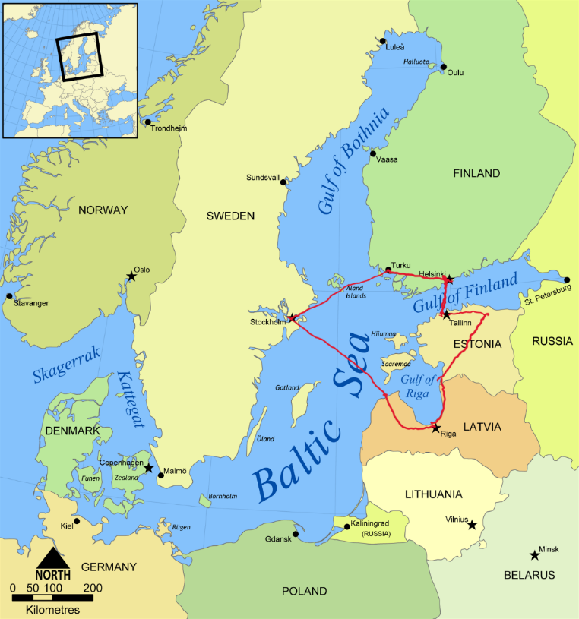

The price of the tour will be from €12,400 (£10,900) per couple/car depending on the category of the room chosen. The prices include a reception and wine with dinner for most evenings, as described below. This will include the cost of car ferries (and outside view cabins) between the countries, for which group bookings will be made by our appointed travel agent, Via Hansa & Borealis. But this price will not include the cost of transport (e.g. Ro-Ro) to the start in Helsinki and return to the UK at the end, which will cost €2,700 (£2,350). Anyone interested in joining this tour should contact Sir John Stuttard at johnstuttard@btinternet.com. Places will be confirmed later, on receipt of a completed application form and a deposit as requested.
Transport by Ro-Ro from the UK to Finland (and return)
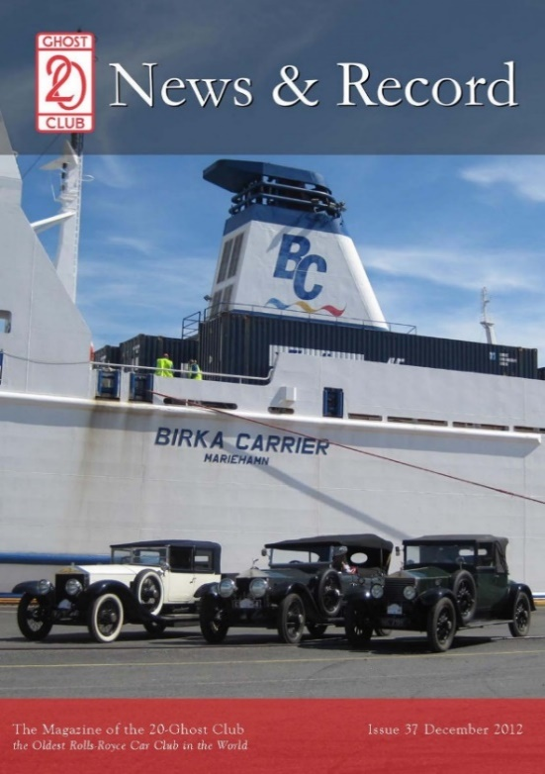
Transporting cars by roll-on roll-off ferries is reliable and inexpensive. We have used Ro-Ro ferries before to convey our cars to/from Finland, including the 2012 Nordic Tour. For those participants starting in the UK and wishing to take advantage of this facility, guidance is given below.

Participants will need to arrange for their cars to be driven or conveyed to the docks in Tilbury either on or before Thursday morning 26th June and then driven onto the Ro-Ro on the
Thursday. A support team of a few volunteer members will be available to monitor/assist. With participants’ approval, our Tour Engineer and one or more volunteering members of the Committee present will drive the cars into the Ro-Ro, to be strapped down by Transfennica for the journey. The club will not take responsibility for this assistance which is provided free at the owner’s risk. Normally marine insurance is not necessary for regular, scheduled Ro-Ro transport ferries, but this is something which should be checked with participants’ insurers.

The contract for transporting the cars by Ro-Ro from the UK to Finland (and return) is between the owner and Transfennica. The club is acting in a facilitating role, having negotiated a discounted price for the return Ro-Ro journey, but takes no responsibility for the transport or handling of members’ cars.

Finland: Helsinki: Three nights: Wednesday 2nd, Thursday 3rd, Friday 4th & Saturday 5th July
Participants will need to make their own arrangements to fly to Helsinki, arriving on, or before Wednesday 4th July. The tour will begin on the Wednesday evening when we have reserved rooms at Helsinki’s finest hotel, The Kämp Hotel, Esplanadi (below left), in the heart of the city (www.hotelkamp.com/en/), with its own underground car park. We will stay at this hotel for four nights and, again, on the final night of our tour, as described below. We will begin on Wednesday with a reception and dinner at Strindberg (shown below right), a classical Finnish restaurant of quality, overlooking Esplanadi, 50 metres from our hotel.

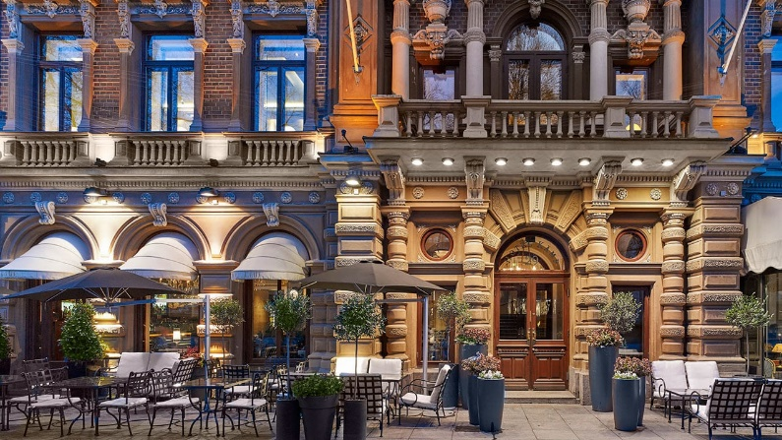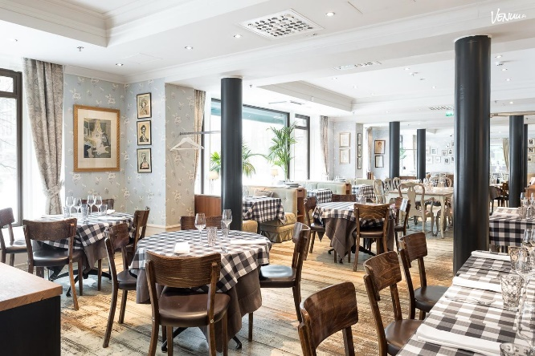

On the Thursday morning participants, whose cars have been transported by Ro-Ro from the UK, will travel by coach, which we have organised, from the hotel to the docks in Hanko (79 miles from Helsinki) to collect their car. On Thursday and Friday evenings, dinners have been arranged at local Finnish restaurants, in walking distance of our hotel. Helsinki is known for the quality of its restaurants based on local food, including fish from the Baltic and from Finland’s rivers. On the Thursday evening, Dr Lasse Lehtinen, formerly an MP and MEP, now a television personality and Finland’s best selling author, will make a presentation ‘An Introduction to Finland’.

There will be an opportunity to spend two further days (Friday and Saturday) sightseeing in this attractive city. For those interested in a short boat ride to the fortified island of Suomenlinna (see photo below), arrangements have been made to spend Saturday morning. Apart from the 19th century fortifications, there is the possibility of seeing the 1915 Silver Ghost (27CB) Barker Tourer which was delivered originally to St Petersburg and then used by Mannerheim in 1918 and 1919 after Finland declared independence from Russia on 6th December 1917 in the wake of the Russian Revolution. The boat will leave from Helsinki’s city centre harbour, near the Cathedral, where there are open markets – an attractive area to stroll around and enjoy a coffee and a light lunch.

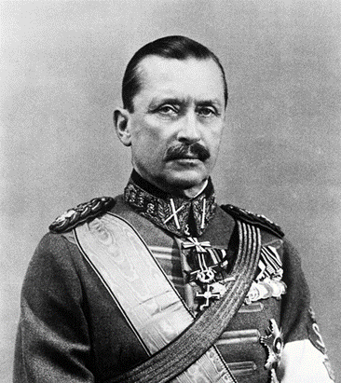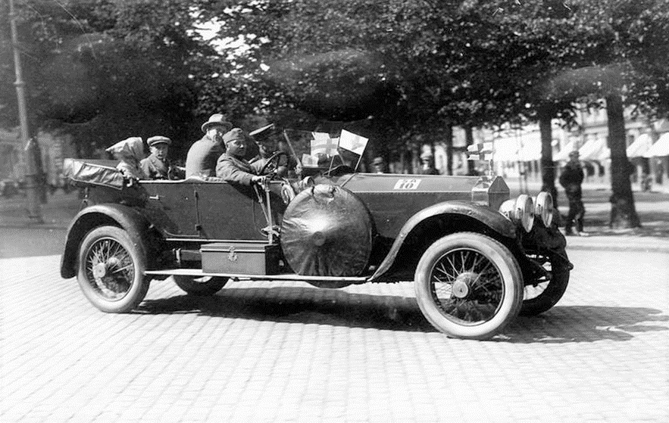

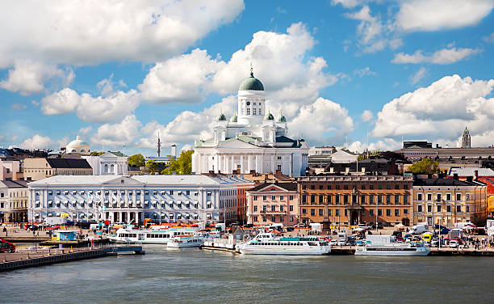
Helsinki Harbour
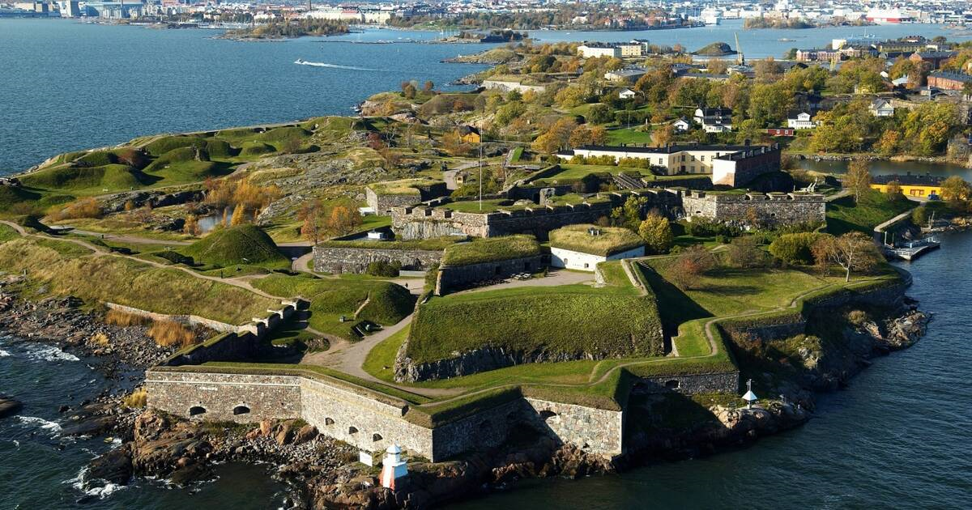
Suomenlinna, the Fortress Island, a UNESCO Heritage site

On Saturday evening, participants will be free to book and dine, at their own expense, at a restaurant in Helsinki. Suggestions will be given in the Route Book.
Finland: Three nights in a country mansion: Sunday 6th, Monday 7th & Tuesday 8th July
On Sunday we will drive to Svartå Slott (in Finnish “Mustio Manor”) (www.mustionlinna.fi/en/), 45 miles west of the capital. Interestingly this 18th century Gustavian building, now owned by the Linder family, was the home in 1912 of Baron Hjalmar Constantin Linder who acquired the first Rolls-Royce to be imported into Finland – a 1912 Silver Ghost (2214) with J Rothschild et Fils Tourer coachwork.

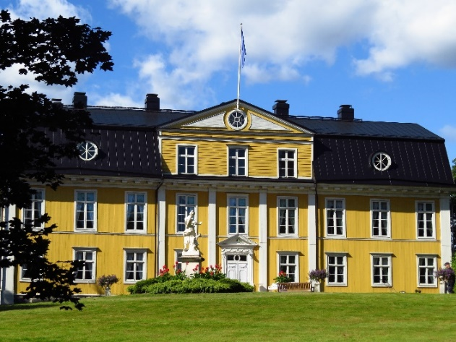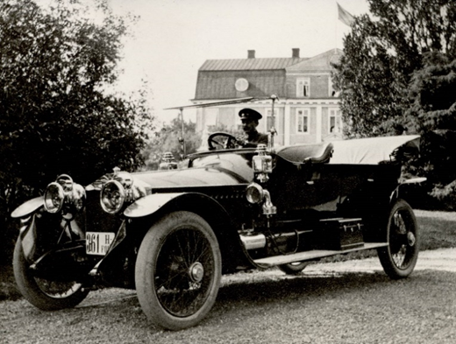

The drive to Svartå Slott on the Sunday morning will take us to Hvitträsk (see images below), with the studios and homes of three famous Finnish architects (Gesellius, Lindgren and Saarinen). They fell in love with the scenery at Lake Vitträsk and built their own houses there, in the National Romantic style. Eliel Saarinen designed, among other buildings, the iconic Helsinki Railway Station (bottom left) and his son, Eero, created many innovative and inspiring structures in the United States, including the TWA Flight Center, New York in 1962 (bottom right). Lunch will be hosted by one of our Finnish members, Bernt Ehrnrooth, at his country estate on Lake Vitträsk.

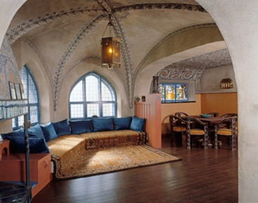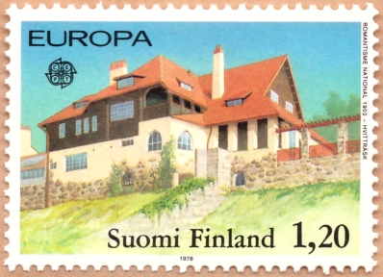

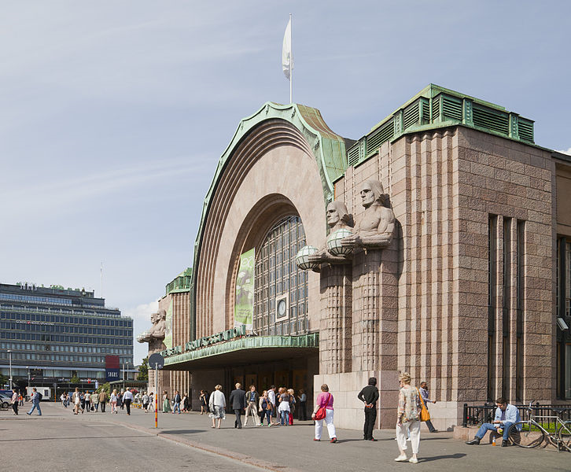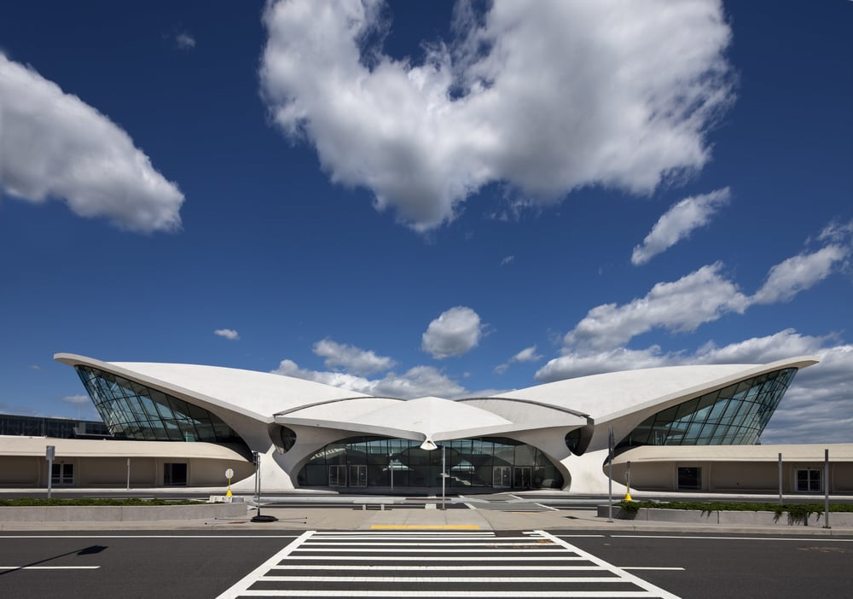

During the time we spend at Svartå Slott, there will be short drives to see the attractive countryside and villages nearby. These will include (1) the attractive seaside town of Tammisaari (lunch has been booked at the Restaurant Knipan shown below left). The market place is shown below right); (2) the 18th Century village of Fagervik (below left middle) and (3) Raseborg Castle (below right middle).

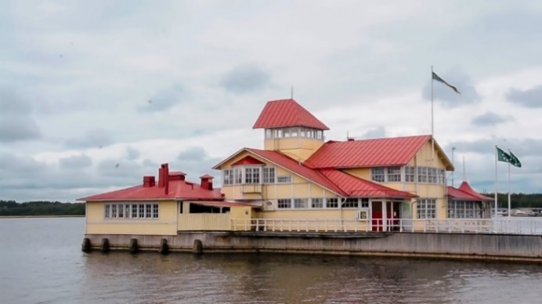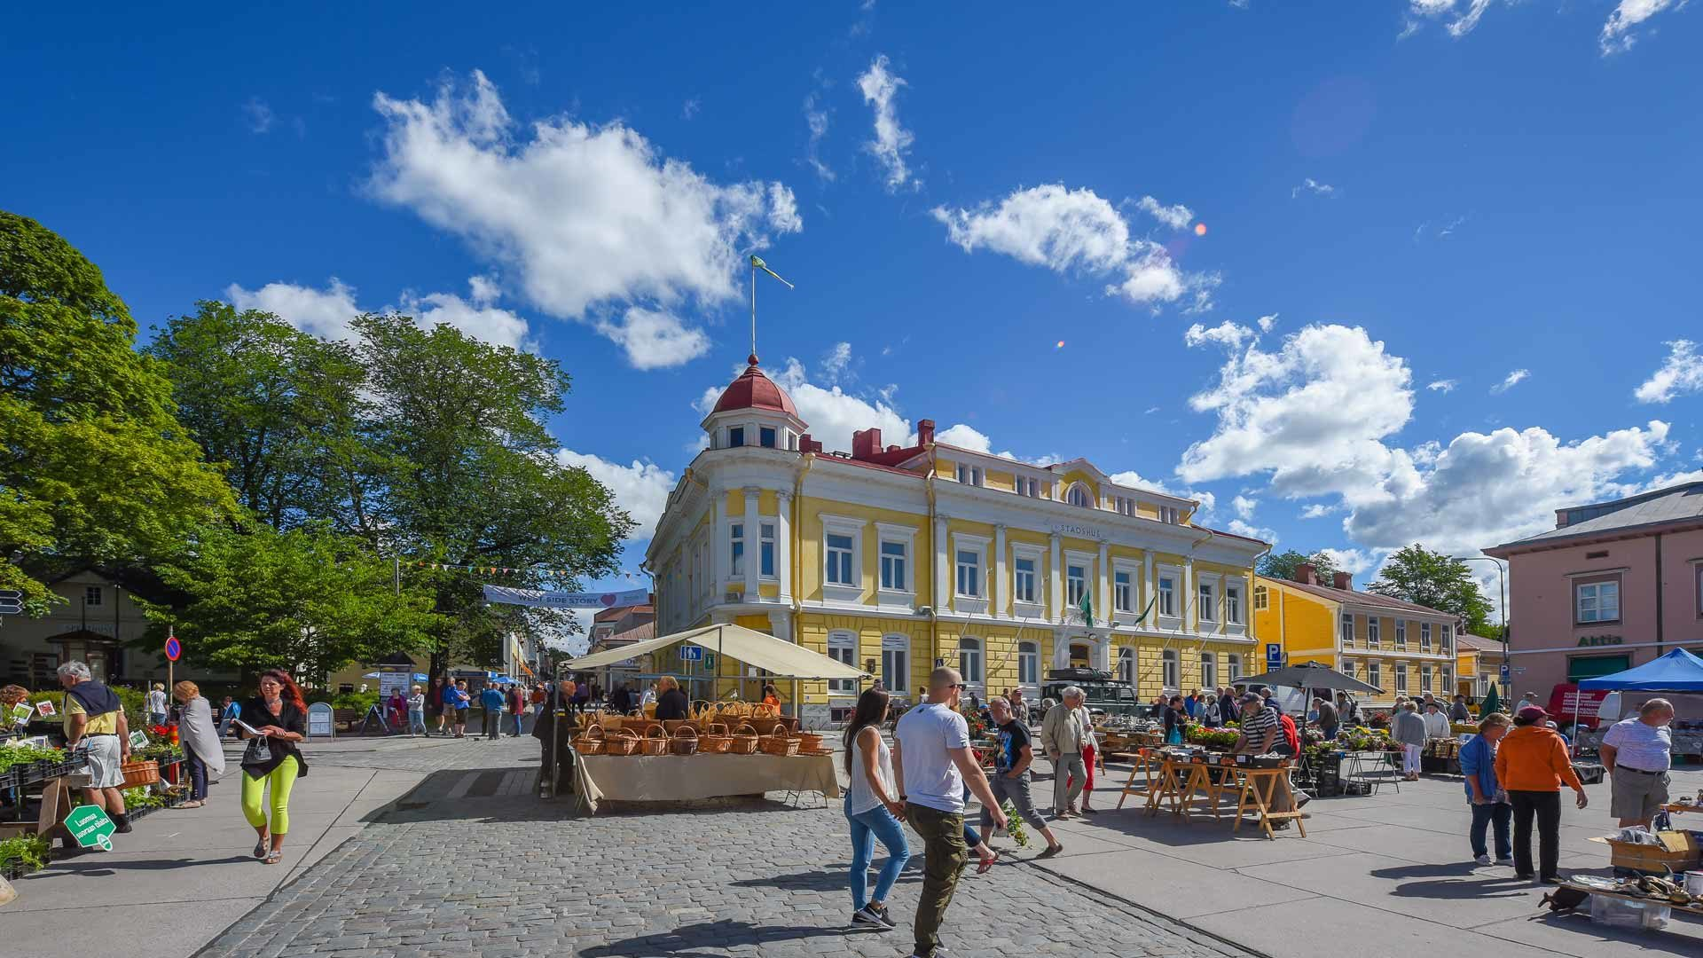

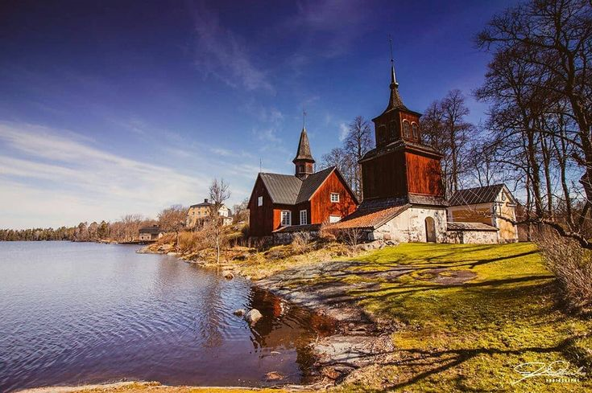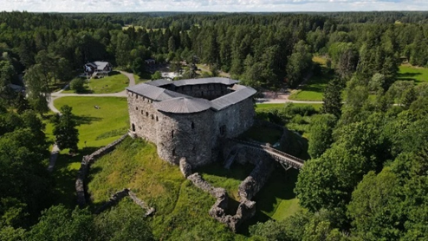

We will visit the picturesque historic ironworks village of Fiskars (below left), whose company still manufactures high quality household and garden implements. On Wednesday 9th July, we will leave Svartå Manor and drive west to Turku to catch the overnight ferry (Tallink/Silja Line) to Stockholm. En route to Turku we will visit the magnificently restored historic Joensuu Manor (below right) owned by a Foundation established by the well-known Finnish businessman, Nalle Wahlroos.

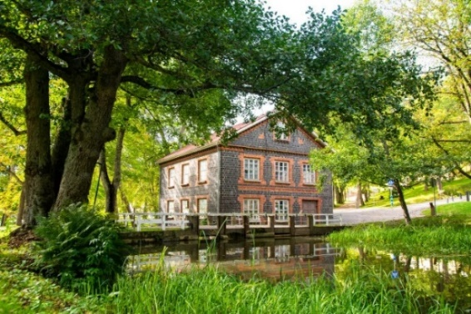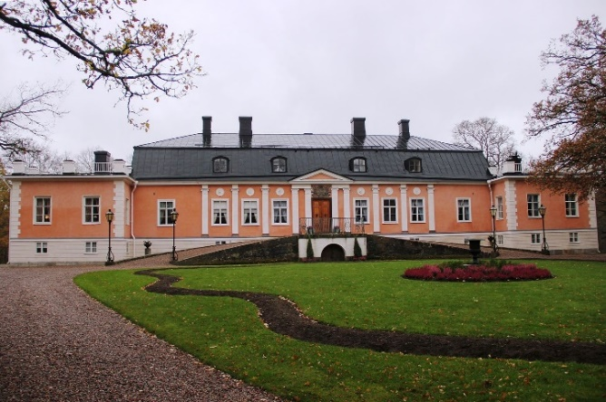

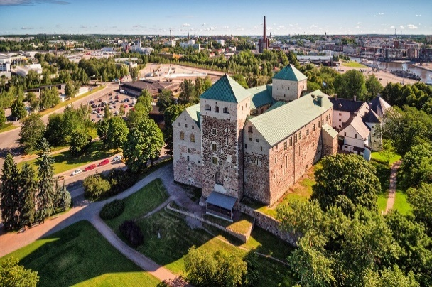
In the afternoon, there will be time to visit Turku, which is the oldest city in Finland and was designated the European Capital of Culture for 2011. A highlight is Turku Castle, dating from the 13th Century. We will embark on the ferry which will sail from Turku at 20.15. Dinner will be provided on board.

Sweden: Stockholm: Three nights: Thursday 10th, Friday 11th & Saturday 12th July
The ferry arrives at Stockholm around 06.00, and it is a short drive to our hotel for the next three nights, Villa Källhagen (www.villakallhagen.se/en/), where we will have breakfast.

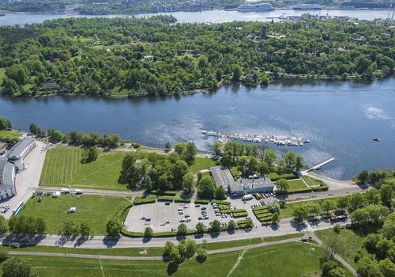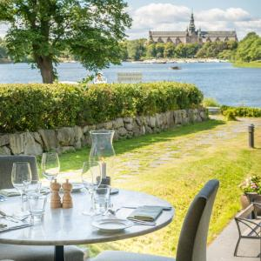

A walk or a short taxi ride to the centre of Stockholm will enable participants to enjoy some of the great sights: (1) The Vasa Museum which houses the remains, and relates the story, of the most powerful ship, Vasa, which sank in the harbour as it was being launched in 1628; the ship was raised to the surface in 1959 and is preserved in the museum – below left; (2) Stockholm old town, dating from the 13th century although most buildings are from the 1600s and 1700s. Highlights include the Baroque style Royal Palace (Kungliga Slottet) and The Royal Chapel (Storkyrkan).

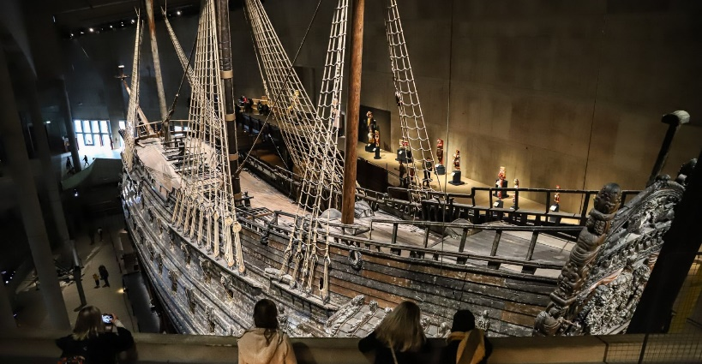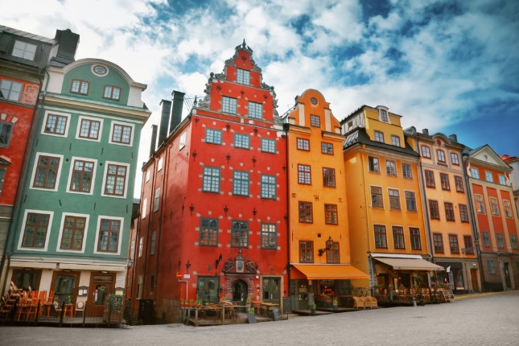

On another day staying at Villa Källhagen, it will be possible to arrange a private tour of Drottningholm Royal Palace or drive 74 kms to Uppsala, below right, one of the oldest cities in Sweden, seeing something of the Swedish countryside.

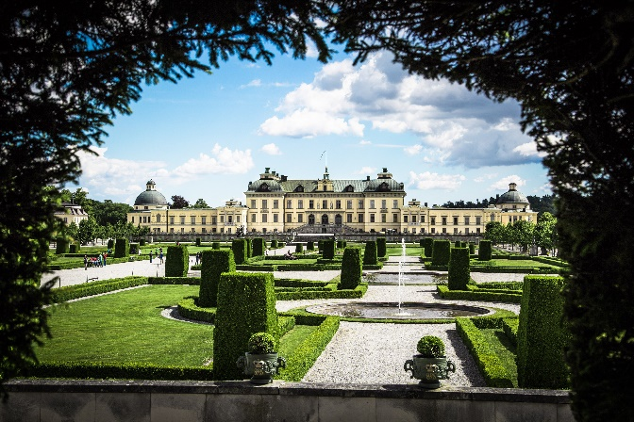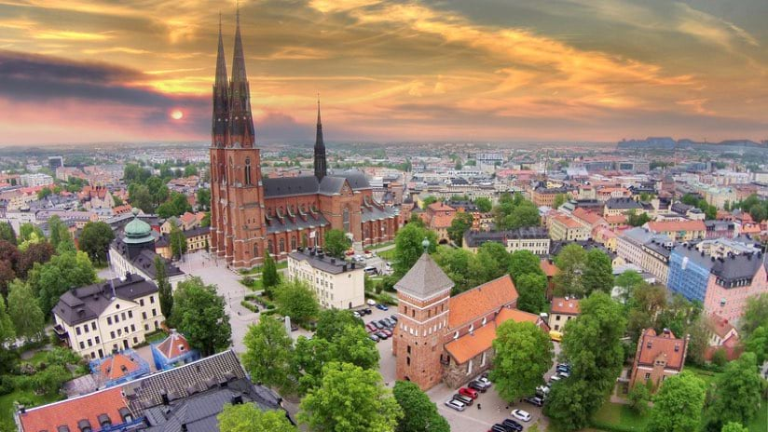

Each evening, we will enjoy cocktails and dinner at our hotel, in its peaceful, enviable location, situated by the side of the water, a view towards the centre of Stockholm.
Latvia: Three nights: Monday 14th, Tuesday 15th July & Wednesday 16th July
After embarkation at 19.30, the overnight ferry (Stena Line) leaves the port of Nynäshamn, 60kms south of Stockholm, on Sunday 13th at 21.30. Dinner will be provided on board. The ship arrives at Ventspils at 07.00 in the morning. 60kms from the port is the attractive town of Kuldīga (below left), where we can have breakfast and then enjoy a guided tour of the Medieval Town, including the Pelči Palace, the Church of St Catherine, and the waterfall and brick bridge over the River Venta. After seeing Kuldīga, it is then a further 145 kms to Riga, where we will stay for three nights at the modern city centre hotel, the Radisson Ridzene, with secure parking. There will be a chance to begin to see Riga in the late afternoon: The Cathedral, St Peter’s Church, St Jacob’s Church, Riga Castle, the Swedish gates and the Three Brothers (the oldest complex of houses in Riga, shown right below). Over the three evenings in Riga, we will enjoy dinner at different restaurants in the Old Town.
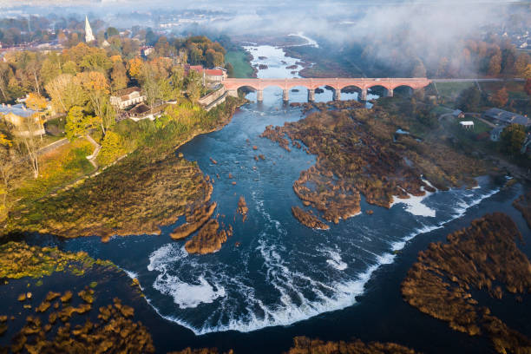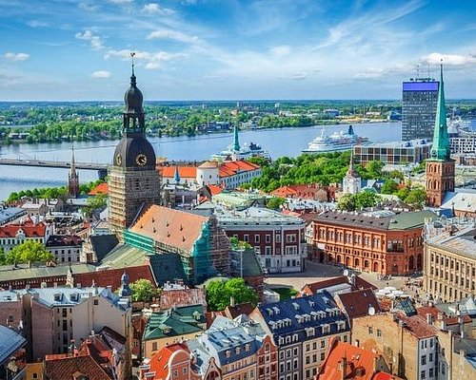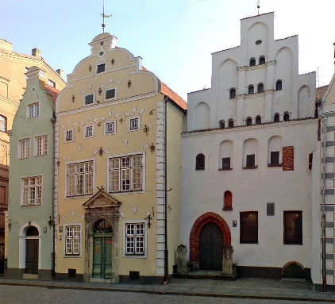

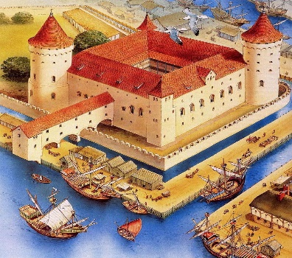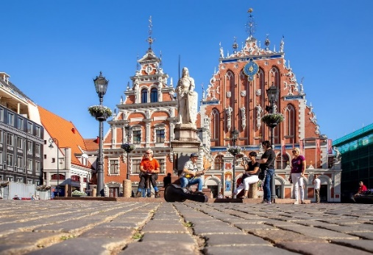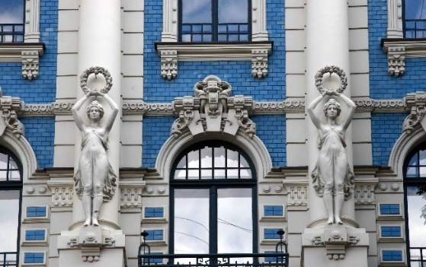
On the second day in Latvia, a drive is planned to visit the dramatic 15th century Bauska Castle and the 18th century Rundāle Palace designed for the Dukes of Courland by Francesco Rastrelli who was also the architect of the Winter Palace in Saint Petersburg and the Catherine Palace in Tsarskoye Selo. A lunch will be organised in the Palace Cellar restaurant before returning to Riga in the afternoon.
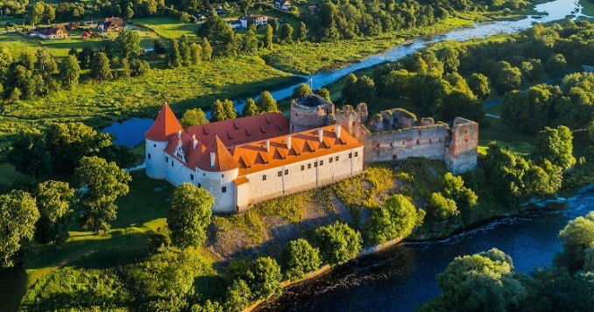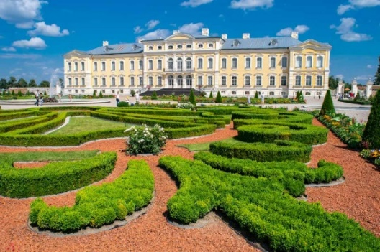
On Thursday morning, on our way to Estonia, there is an opportunity to see the Riga Motor Museum, the largest old car motor museum in the Baltics. Its exhibits include a replica of the 1938 Auto Union racing car Type C/D and many Russian cars from the 1920s/30s and post WWII. There is also the Rolls-Royce Silver Shadow in which Brezhnev had an accident in Moscow in 1980.
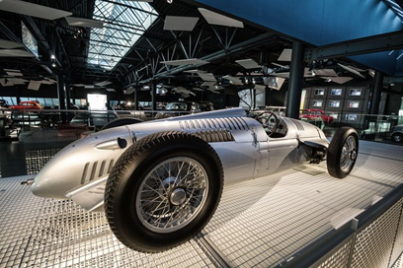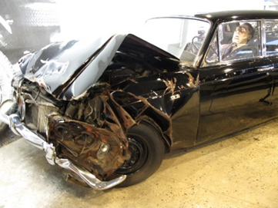
Estonia: Six nights: Thursday 17th to Wednesday 23rd July
After 183kms on our coastal journey north from Riga, we come to the attractive Estonian seaside town of Pärnu with its magical art nouveau hotel Villa Ammende, where we will stay for one night. Accommodation at the Villa Ammende (below left), where drinks and dinner will be served, will be supplemented with rooms at the nearby the Hedon Spa (below right)
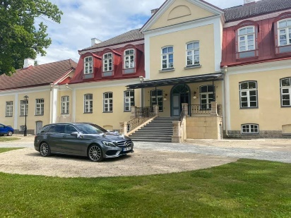
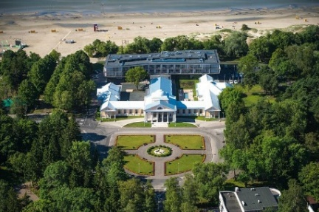
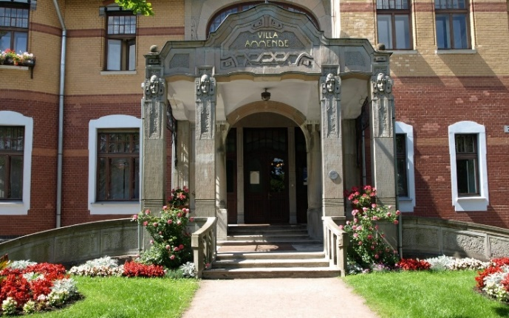

From there, with lunch en route at Purdi Manor (shown above right), it is 196 kms to the 19th century Vihula Manor, an estate in northern Estonia owned by the German Baltic Schubert family. After suffering in the aftermath of WWII, the house was extensively restored and opened as a hotel in 2012.

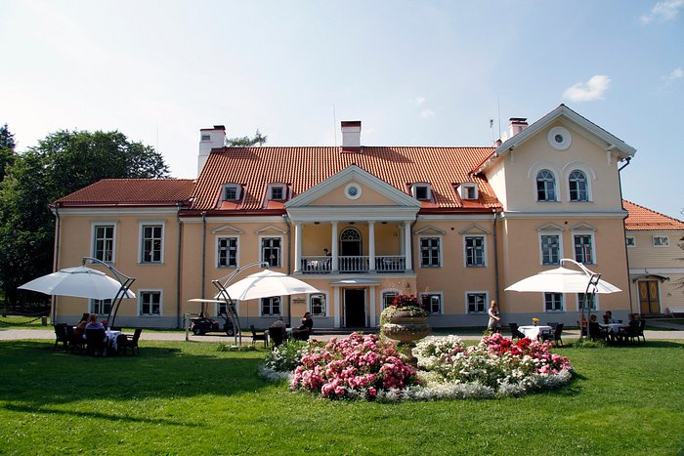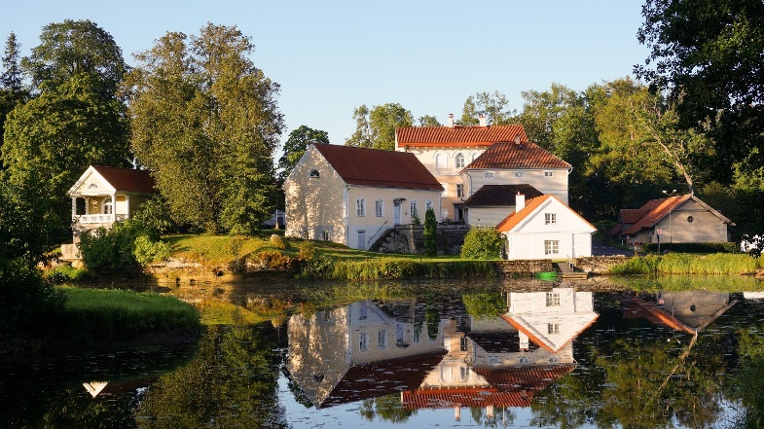

We will stay at Vihula Manor, shown above, (www.vihulamanor.com/) for three nights, relaxing at this country manorial estate, with spa, before travelling 93 kms to Tallinn, the capital of Estonia. Our hotel is the Von Stackelberg (www.vonstackelberghotel.com/), shown below left) where we will stay for a further two nights to see the old city of Tallinn.

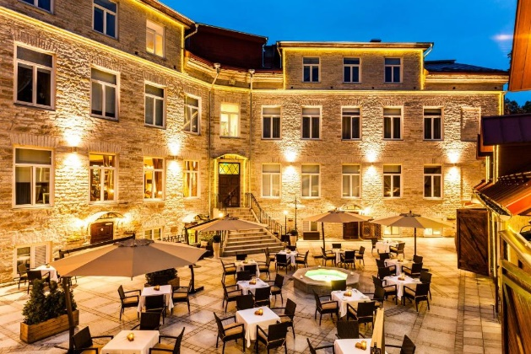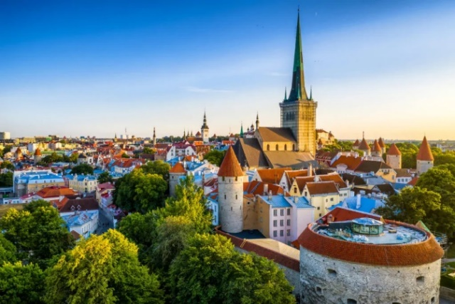

On the first night, there will be a reception at the Von Stackelberg followed by dinner in the courtyard, if the weather permits.
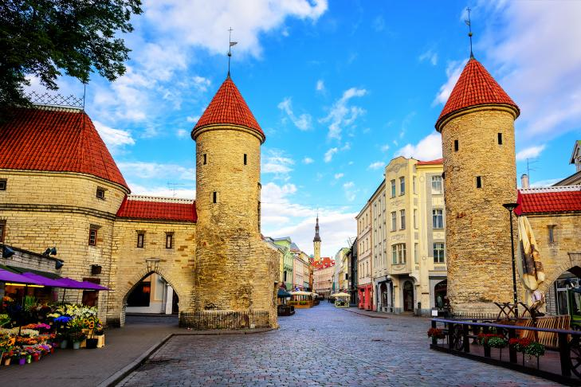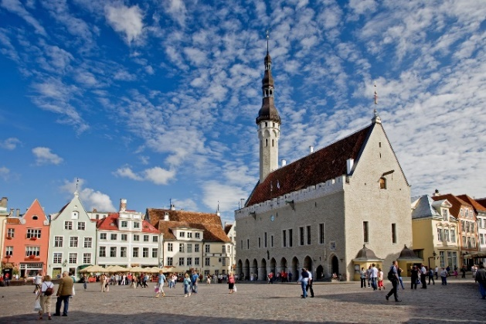

On the second night in Tallinn, a dinner will be arranged at one of the city’s fashionable restaurants.

Finland: Helsinki: One night: Wednesday 23rd July
On Wednesday morning, embarking at 09.30, we will take the short (two hour) Tallink ferry, leaving Tallinn at 10.30 and arriving at 12.30 in Helsinki. We will lunch at the Café Ursula on the sea front and then return for the final night of our tour to the Kämp Hotel. On the day we arrive, passengers and luggage can be offloaded at the Kämp Hotel in the afternoon and the cars can then be driven to the Hanko docks to be parked for the return Ro-Ro journey to the UK. A coach has been organised to bring participants back to Helsinki for the final dinner. For those returning to other countries, cars can be parked in the underground garage of the Kämp Hotel.

Dinner on the final night of our tour will take place at the spectacular Swedish Yacht Club, shown below, on a small island in Helsinki’s harbour.

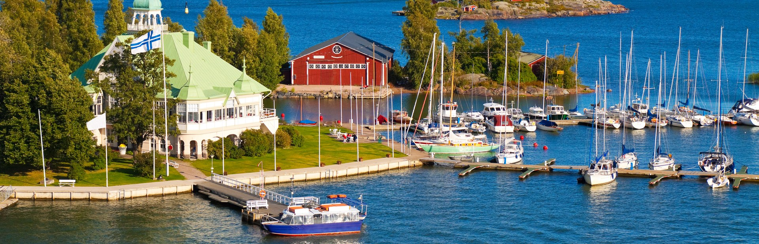

If participants take the afternoon flight back from Helsinki to London on the Thursday, this will give further time for sightseeing in Helsinki. Of course participants can always stay an extra day or so in Helsinki after the tour has ended.

The Ro-Ro returning the cars to the UK will arrive at Tilbury on Wednesday morning 30th July when owners should make arrangements to drive their cars from the Ro-Ro or collect them from the docks. Again, a support team of a few members will be on hand to monitor and assist.

Anyone wishing to join this tour should complete the booking form and send it to Sir John Stuttard at johnstuttard@btinternet.com.

The Baltic Region in Summer
A 22-night tour of Finland, Sweden, Latvia & Estonia
Wednesday 2nd July to Thursday 24th July 2025

Please scan/send this form to johnstuttard@btinternet.com to apply for a place on this tour.

I would like to join this tour of 22 nights starting in Helsinki on Wednesday 2nd July 2025 and finishing in Helsinki on Thursday 24th July 2025. The price of the tour will be fixed in euros from €12,400 (£10,900) per couple depending on the category of the room chosen. The prices include D, B&B, except where stated, with a reception and wine with dinner for most evenings, as described in the flyer, and are based on likely rates of inflation in 2024 and 2025. They are also based on an exchange rate of €1.14 to the £ and will be adjusted if rates change. A deposit of €3,000) or £2,600 is required to secure a place on this tour. Members are encouraged to pay in euros rather than pounds, but please do not remit the deposit until you have a confirmed place. Note: deposits are non-refundable in the event of cancellation unless a substitute is found, or hotel credits obtained. The tour will start and end in Helsinki. Discussions have taken place with a leading Ro-Ro company, Transfennica, to convey cars from the UK (Tilbury) to Finland (Hanko) return. The tour prices stated below do not include the return cost of this Ro-Ro transport. The cost will be €2,700 (£2,350) per car for the return journey. The names of members interested in transporting their cars to/from Finland via Ro-Ro will be given to Transfennica, after which Transfennica will require information from members about their car details and Transfennica will contract with members.

Full names of driver and passengers: …………………….……………………………………………………..…………………………..

Address: ………………………………………………………………………………………..…………………………………………..

E-mail address: ……………………………………………………………………………………...............................................................

Mobile phone telephone number/(s) on tour……………….………………………………………………………………………….……..

Passport number and date of expiry for Driver……………………………...………Passenger………………..….……………..…………

Dietary requirements, if any...........................................................................................................................................................................

Please give my name and e-mail address to Transfennica for return Ro-Ro transport from the UK to Finland

Please indicate your order of preference (eg 1 or 2) for your preferred category of room (Classic or Deluxe) in the first two boxes below and send a deposit of either €3,000 or £2,600 to the appropriate bank account of the club, given below. Please advise Philip Hall, the club Treasurer when you have remitted funds: pah.rr@btinternet.com

Classic – (€12,400 or £10,900)  Deluxe – (€12,900 or £11,400)
The size, aspect and quality of each category of room increase with the price. In addition, on the one night stop in Pärnu, Estonia, Classic rooms are in the nearby Hedon Spa, while Deluxe are in the Villa Ammende.
Type of bed: Double or twin …………………………….

Car: Model............................................................................. Chassis No........................ Reg No............................... Year.....................

Body style/type....................................................................Colour(s)..................................................

As a participant in this event and in consideration of the right and privilege to enter and participate in this event and intending to be legally bound, I agree to release The 20-Ghost Club Limited and all committee members and its representatives from any and all liability and injuries, damage or loss or consequential loss arising from my entry and participation in the event. I also agree that information about the participating car, the names of the driver and passengers, including photographs taken during the event and tour, may be published in the Club’s journal, News & Record, unless I inform the Editor by e-mail that I do not wish such information and/or photographs to appear. I confirm that I will have public liability insurance cover in place for the four countries should I be accepted for this tour/event. I further confirm that I have read and understand the Club’s rules relating to tours (deposits and cancellations) contained in paragraphs 10 to 13 of the Club Rules contained in the Members’ section of the Club’s website under Statutory & Legal.

Signed……………………………………………. Dated …….................................

Bank account for pounds sterling:  Bank – Lloyds;  Sort code: 30-96-35  Branch: CARFAX OXFORD  BIC: LOYDGB21023  IBAN: GB69 LOYD 3096 3500 0668 03  Account name: The 20-Ghost Club Limited  Account no: 00066803 | Bank account for euros:  Bank - C Hoare & Co  37 Fleet Street, London EC4P 4D  Account Name: The 20-Ghost Club Ltd  Sort Code: 15-99-00  Account No: 27487380  IBAN: GB88 HOAB 1599 0027 4873 80  BIC: HOABGB2L

Note: The hotels and itinerary shown above are based on current plans and confirmations. There may be unavoidable changes to hotels and other plans.

