**South Downs Roller Coaster!**

**THURSDAY 2nd, FRIDAY 3rd, SATURDAY 4th, and SUNDAY 5th OCTOBER 2014**

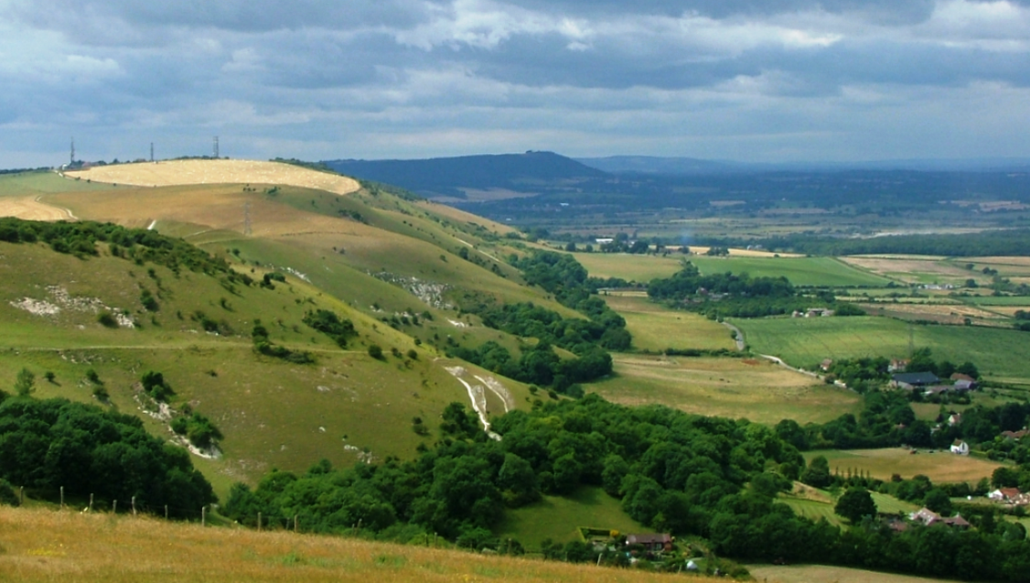

After last year’s autumn weekend in Norfolk, by contrast this year we plan to explore The South Downs National Park, Britain’s newest National Park up and down the rolling downs along the South Coast of East and West Sussex.

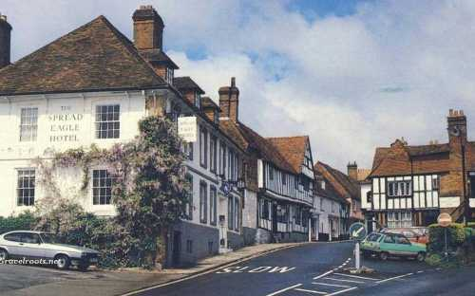

We are staying at the Spread Eagle an old coaching inn at Midhurst which has easy access to the Region and can also be reached without the need to go on the M 25! Arrive on Thursday evening, as on Friday we have been invited by Rolls-Royce Motor Cars at Goodwood. The plant fits in astonishingly well within the countryside and equally impressive is the way the plant keeps on being re-configured as the model range and number of cars produced increases year by year.

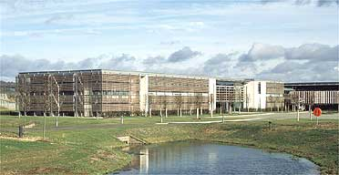

From ultra modern manufacturing you can then go back several hundred years and experience rural life at the Weald and Downland Open Air Museum as it was in the Middle Ages. As well as a huge sawpit, there is a working water driven flour mill as well as several houses put back as they were in the 16th C. Moving forward a few centuries there is Tangmere Aircraft Museum which was a centre of activity in the Battle of Britain. They have the first Spitfire, a Hurricane as well as their successors , a Supermarine Swift and Lightning from the 1950s and 60s,

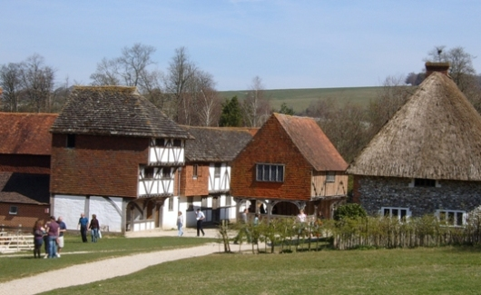

This western part of the National Park has some glorious sweeping country roads going up and over the South Downs .

On Saturday and Sunday, we can explore the wide variety of different types of countryside and heritage that this area possesses. To the south near Chichester there is a very impressive Roman Villa complete with wonderful intricate under floor heating and baths.

At the Eastern end of the Park we will explore Bodiam Castle, described as “an old soldier’s dream castle,” built as a quadrangle surrounded by a moat given by Lord Curzon to the National Trust.

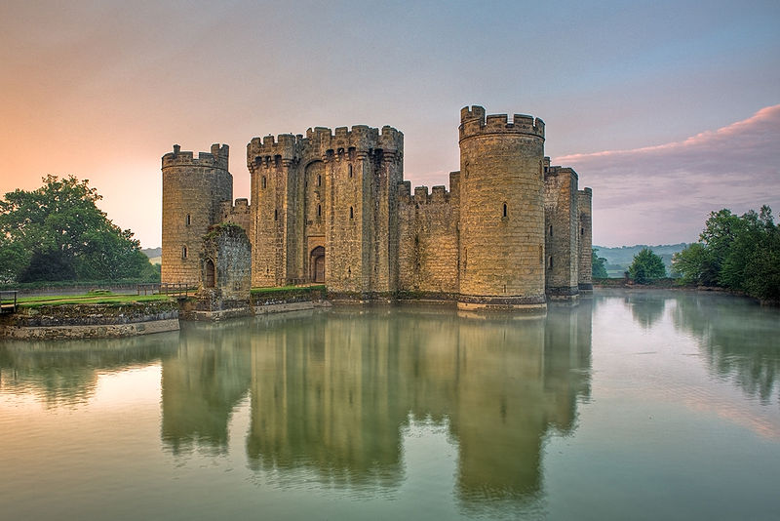

As we turn west, we will test our cars abilities on some of the South’s historic hill climbs up the side of the Downs. Weather permitting this should give us some wonderful views of the Weald to the North and the English Channel to the South.On our way, we will pass Cuckmere Haven and the famous Seven Sisters chalk cliffs before going inland past Glyndebourne and over Ditchling Beacon the site of one of the highest beacons lit to warn of the approach of the Spanish Armada.

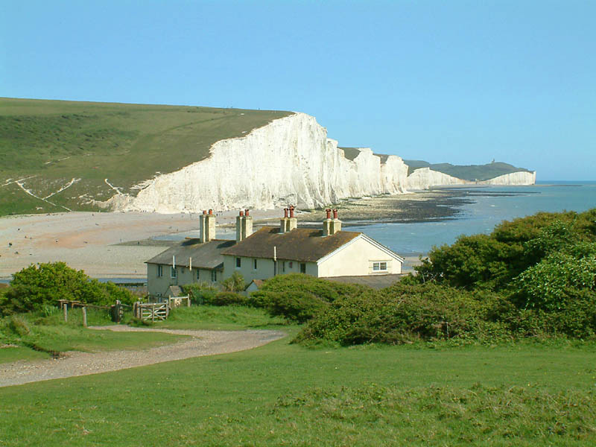

For those interested in the industrial heritage of the region the Amberley Museum and Heritage centre has a fascinatingly eclectic collection of old commercial vehicles, steam engines, garage workshops, as well as many craftsmen practicing ancient skills.

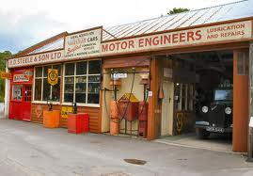

In addition there are also many very fine National Trust Houses in the area where you can stop if you prefer houses to industrial heritage The choice is hugely varied, coupled with wonderful driving on minor roads that are relatively free of traffic.

**Estimated cost £795 per couple for 3 nights covering dinner, bed and breakfast. Because spaces are limited please can you send a deposit of £265 and the attached entry form as soon as possible to Tim Forrest**

**South Downs Roller Coaster!**

**THURSDAY 2nd, FRIDAY 3rd, SATURDAY 4th, and SUNDAY 5th OCTOBER 2014**

Please can you complete your entry and pay the deposit of £265 now. We will send further details and confirm the final cost for the three nights of Thursday, Friday and Saturday. Equally if there are any particular venues you would like to see on the tour please let Tim Forrest know and we will see what can be arranged. Email him on **forresttim@aol.com**

**To: Tim Forrest,** Botley House, The Green, C hiddingfold, Surrey, GU8 4TT

Names…………………………………………………………………………………………………………

[ ] I now enclose a cheque payable to “20-Ghost Club Limited” to cover the balance of my payment:

[ ] I have made a direct transfer to the bank - Santander " The 20 Ghost Club Ltd " a/c 40583506 - sort code 090666 - BIC ABBYGB2LANB - IBAN  GB09 ABBY 0906 6640 5835 06 to cover the deposit for the tour.

I/We have National Trust membership. (Please delete accordingly)

Suggestions/special needs if any

*Signed……………………………………………………………………………………. Date .............................*

Model………………………….…..Chassis No……………..Reg No………….……….Colour…………………………

Year “On test”……………….. Body style……..…….………………. Coachbuilder…………………..…………..…….

*As a participant in the 20-Ghost Club South Downs Weekend, October 2014 and in consideration of the right and privilege to enter and participate in this event and intending to be legally bound, I agree to release the 20-Ghost Club and all committee members and its representatives from any and all liability and injuries, damage or loss or consequential loss arising from my entry and participation in the event. I confirm that I have a valid driving licence, that my car is currently licensed, insured, is roadworthy for the event and both complies with the current vehicle regulations for the country in which the car is registered.*

*Signed…………………………………………………………………………… Date .............................*