

**Champagne to Provence**

**Friday 7th June to Tuesday 18th June 2024**

**The 120th anniversary of the founding of Rolls-Royce**

**and of the Entente Cordiale between England and France in 1904**

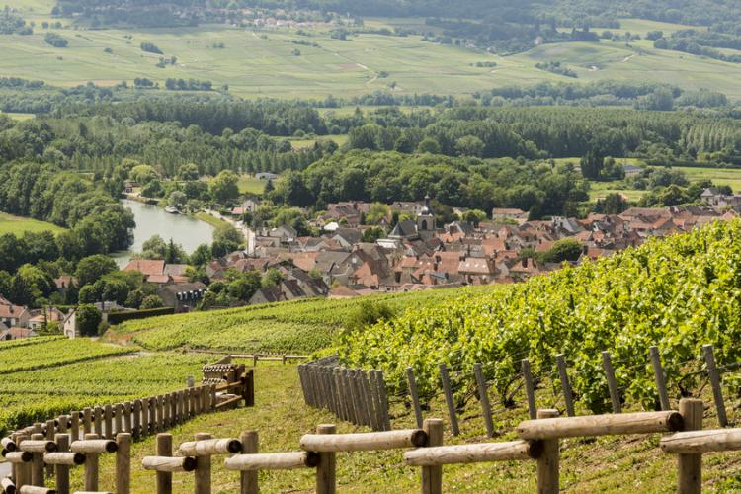

Champagne vineyard near Épernay Lavender fields in Provence in June

**Introduction**

France is noted for its food and wine, as well as its châteaux, historic towns, beautiful gardens and attractive countryside. Travellers often use autoroutes and routes nationales, leaving the smaller ‘D’ roads ideal for pre-War motor cars. A 11-night tour has been arranged to travel, on these smaller roads, through the countryside and the wine growing areas of Champagne, Burgundy and Côtes du Rhône, before spending almost a week in Provence, an attractive part of the country. There will be a few wine tastings planned. The tour will commemorate the 120th anniversary of the founding of Rolls-Royce and of the Entente Cordiale between England and France in 1904. The hotels have been chosen for their character and charm, their country setting and the quality of their food. The map below shows the approximate route in green with our luxury hotels in blue blobs.

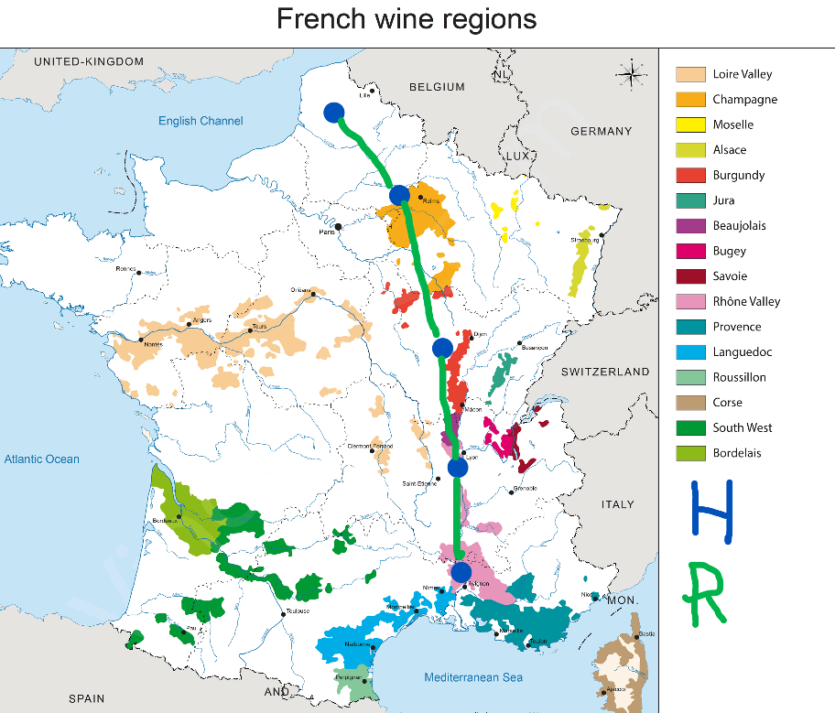

**La Chartreuse du Val Saint Esprit**

The tour will begin in Fère en Tardenois in the Champagne Region of France. For those driving from the UK via the Channel Tunnel, the distance from Calais to Fère en Tardenois is 162 miles. If you wish to break that journey, a hotel recommended for an overnight stop is La Chartreuse du Val Saint Esprit, 1 rue de Fouquières, 62199 Gosnay, Tél: +33-3-21-62-80-00, where we spent our final night on the WWI Commemorative Tour in 2014. This hotel is 50 miles from Calais and then it is just 118 miles on to Fère. The hotel menu is augmented with produce from an extensive market garden. This stop is not part of the organised tour. Please book your stay directly if you wish to break your journey: [levalsaintesprit@lachartreuse.com](mailto:levalsaintesprit@lachartreuse.com)

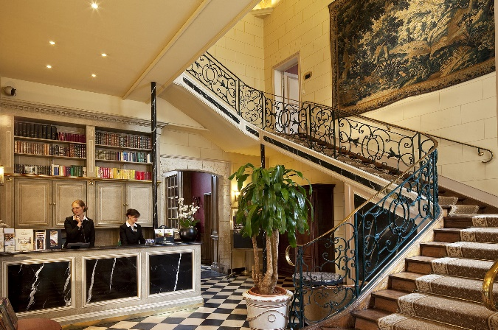

La Chartreuse du Val Saint Esprit

**Champagne Region (three nights: Friday 7th, Saturday 8th, Sunday 9th June)**

In Champagne, which is the start of our tour, we will stay for three nights at the picturesque five star Château de Fère en Tardenois, 30 miles northwest of Épernay: <http://www.chateaudefere.com/en/>, with its gastronomic restaurant. This will provide a base for drives around the attractive Champagne region and a visit to a Champagne house as well as to Châlons-en-Champagne with its St Stephen's Cathedral and the 14th century Notre-Dame-en-Vaux, listed as World Heritage by UNESCO, which has a carillon of 56 bells, one of the largest in Europe. The grand city of Reims is also close by.

It was from Fère en Tardenois that one of the most famous Rolls-Royce car journeys began. In October 1914, Colonel Tom Bridges was ordered by General French to drive the General’s Silver Ghost to Antwerp, to try to persuade the Belgian King not to evacuate the city, in the face of the German advance. He drove the 600kms, leaving at 05.00. Arriving at 22.30 he went directly for an audience with the King, whom he managed to persuade to delay the evacuation by a day or so, before Antwerp fell. See attached image on the cover of the original publicity booklet issued by Rolls-Royce celebrating Rolls-Royce’s part in the conflict. We can celebrate the 110th anniversary of this historic drive when we visit Château de Fère en Tardenois in 2024. In the photo below left, you will see the ruins of the 13th century castle and the “modern” classic 17th century building, now our hotel.

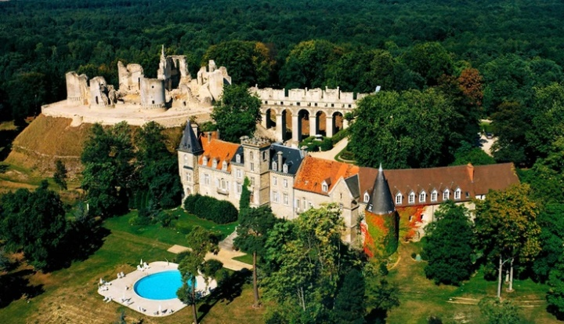 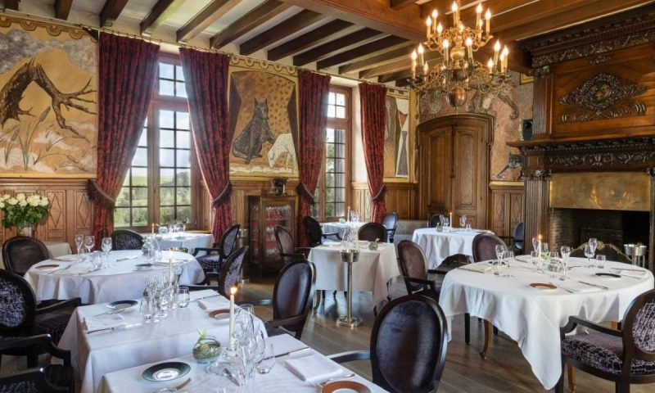

Château de Fère en Tardenois

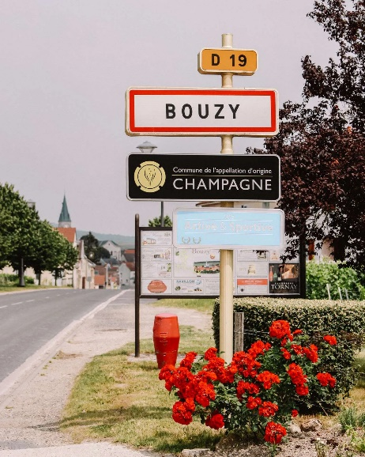

A tour around the Champagne Region

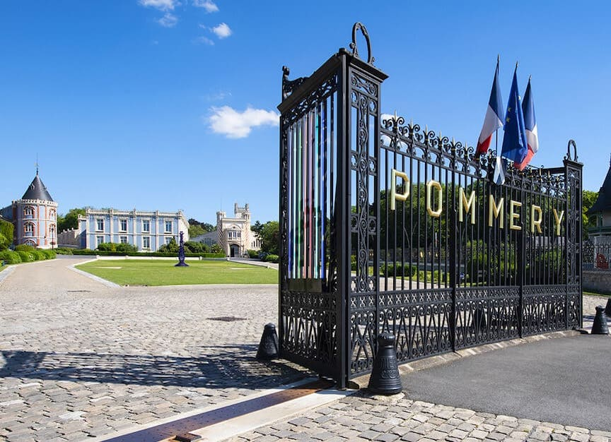

Left: La Maison Pommery in Reims

Right: Notre-Dame-en-Vaux church in Châlons-en-Champagne

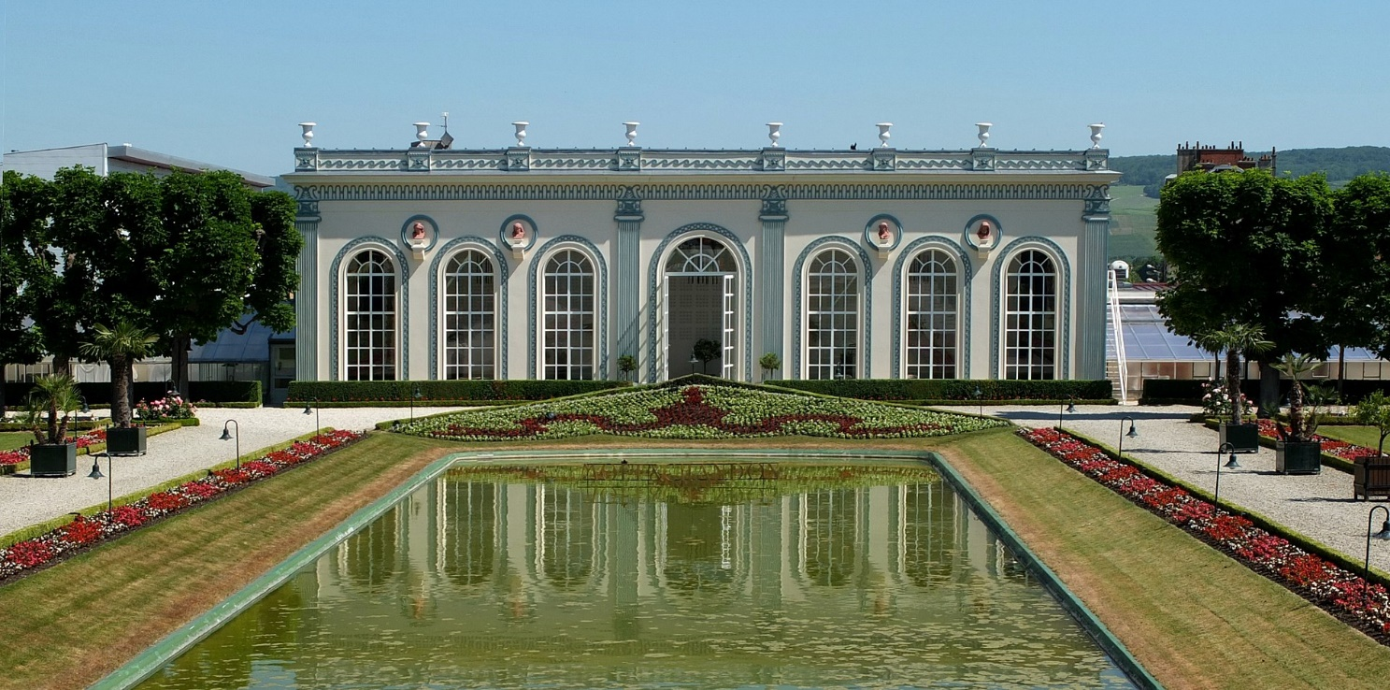

L'Orangerie de Moët & Chandon on Avenue de Champagne, Épernay

A visit will be arranged to one of the famous champagne houses.

**Burgundy Region (three nights: Monday 10th, Tuesday 11th, Wednesday 12th June)**

The 180-mile journey from the Champagne Region to the Burgundy Region takes us on minor ‘D’ roads through rural France, crossing the Aisne, Marne and Seine rivers. There are plenty of small towns and attractive villages for a lunch stop. Then, in the afternoon, near Montbard, we can stop and visit the 12th century Cistercian L’Abbaye de Fontenay, built in the Romanesque style.

Montbard L’Abbaye de Fontenay

After this, it is a short distance to our four star hotel, shown left below, the Hotel Golf Château de Chailly, which is 48kms northwest of Beaune: <https://www.chailly.com/en/>

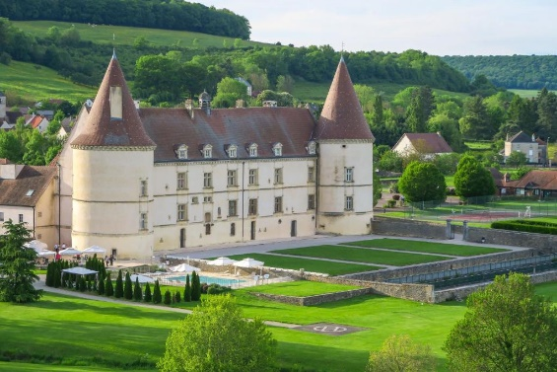 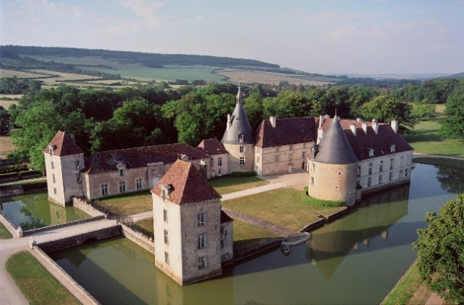

Château de Chailly Château de Commarin

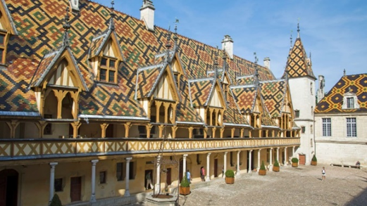

The Hospices de Beaune, founded in 1443 Beaune centre, capital of Burgundy wines

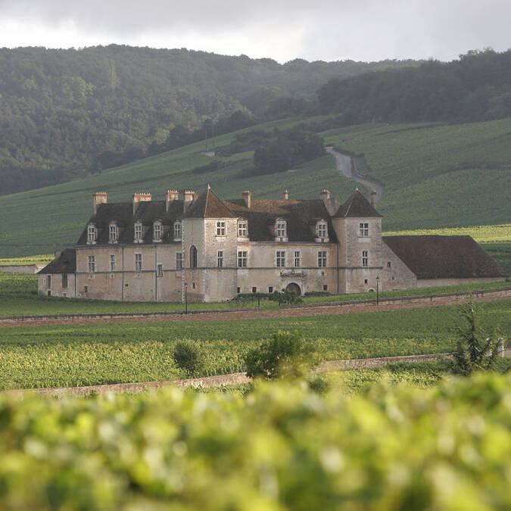

Left: Château de Savigny-lès-Beaune also has a large collection of cars, motorcycles and airplanes

Right: Château du Clos de Vougeot, owned by the Brotherhood of the Knights of the Tastevin

**The Rhône Valley (Thursday 13th June)**

Over the next two days we will travel south from Château de Chailly along the Rhône Valley. On the first day the distance of 150 miles will take us through the southern part of Burgundy where the white Chardonnay wine of Lugny and Mâcon can be found. The journey takes us around the city of Lyon and through Vienne.

Just west of Mâcon, we will pass Cluny Abbey, a former Benedictine monastery founded in AD910 which became hugely influential in the Catholic Church, supporting the revival of the Papacy. Although Cluny Abbey was the largest church in Christendom until the completion of Rome's St Peter's Basilica in the early 17th century, it was almost totally destroyed during the French Revolution. But the remains are interesting, including the Bell Tower (shown left), built in the 10th century.

After that the route takes us through Chatillon d' Azergues with its ruined 13th to 15th century castle, which dominates the village, and the 12th century Chapel of Saint-Barthélémy. Then we pass through the Medieval village of Charnay.

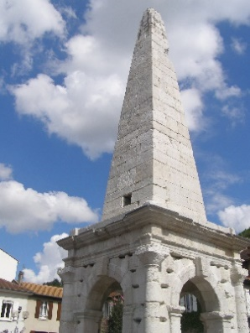We will by-pass the important city of Lyon, but the town of Vienne is worth a stop to see its Roman remains dating from the 1st century BC - in particular, its Temple, Amphitheatre and Pyramid.

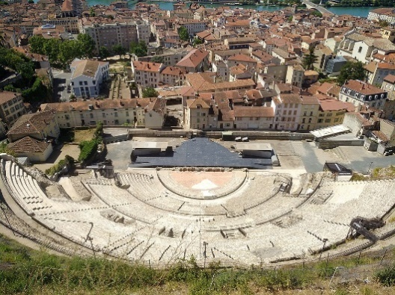

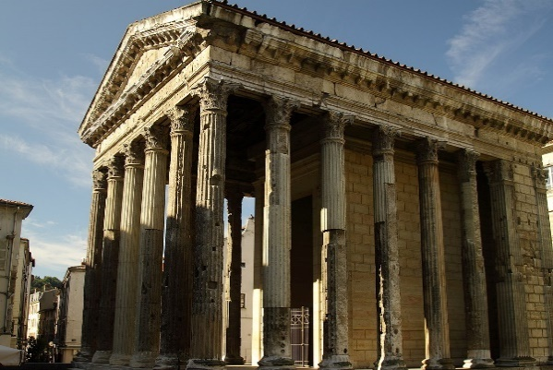Vienne also has buildings from a later era – the 12th century Cloître Saint-André-le-Bas and the 12th to 14th century Cathédrale Saint-Maurice, both shown on the left.

Our hotel, which has been planned but not yet confirmed, for the night is the four star Hotel Beau Rivage (left below), in Condrieu on the west bank of the Rhône: <https://www.hotel-beaurivage.com/en/> If you arrive early, visit Sainte-Croix-en-Jarez (right below), listed as one of the most beautiful villages of France, 10 miles to the east of our hotel.

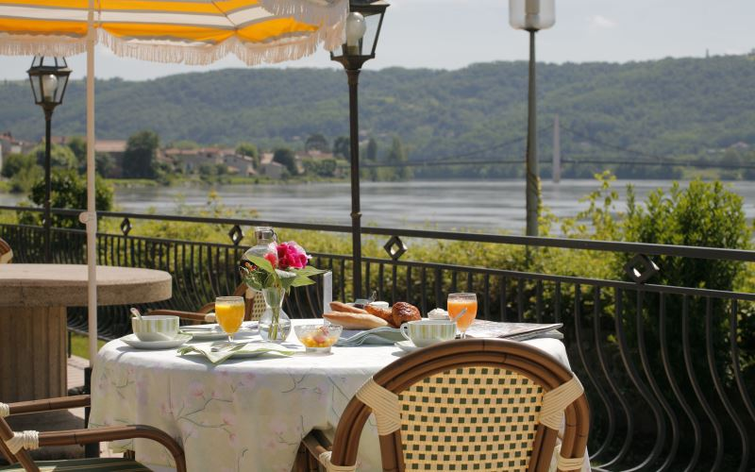 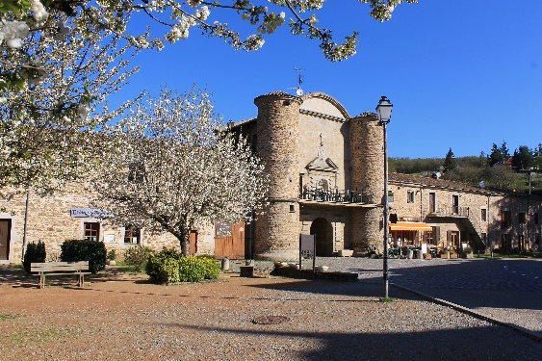

**The Côtes du Rhône Region (four nights: Friday 14th to Tuesday 18th June)**

The drive from Condrieu to the main hotel of our tour in Bagnols-sur-Cèze, south of Bollène, is 100 miles, continuing south following the Rhône River. We will travel on the small ‘D’ roads on the west bank of the river. If you like gardens, then Le Jardin d’ Eden at Tournon, 30 miles south of Condrieu, is worth a visit (shown below). There are many attractive towns and villages for lunch. In the afternoon we will pass through the town of Montélimar, fabled for its delicious nougat.

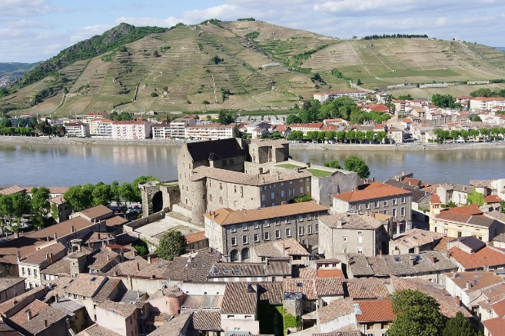

Our hotel for the next four nights is the elegant and gastronomic, and recently renovated, Château de Montcaud in the countryside, two miles west of Bagnols-sur-Cèze and 25 miles north-west of Avignon: <https://www.chateaudemontcaud.com/en/>

This is a great base from which to enjoy short excursions to see the treasures of this region:

* A visit to Avignon with its ancient and grand Palais des Papes
* A visit to the attractive town of Vaison-La-Romaine with its Roman ruins and Medieval buildings
* A tour to Les Antiques (with its 2,000 year old mausoleum and triumphal arch) and Les Baux-de-Provence, one of the most beautiful villages in France (with many historic monuments) and the Pont du Gard, the enormous and astonishing Roam aqueduct
* A tour to the summit of Mount Ventoux, for decades the scene of motor car hill trials and now one of the stages of the Tour de France cycle race
* A tour including the dramatic Dentelles de Montmirail and the wine-growing villages of Gigondas and Beaumes-de-Venise
* A visit to Châteauneuf-du-Pape to taste its Grenache-based red and rarely available, white wines

At our hotel, we will enjoy a Barbeque on one evening. We will have a wine tasting with the local Compagnie du Côtes du Rhône Gardois.

The bridge at Avignon The Palais des Papes at Avignon

Vaison-La-Romaine Les Antiques

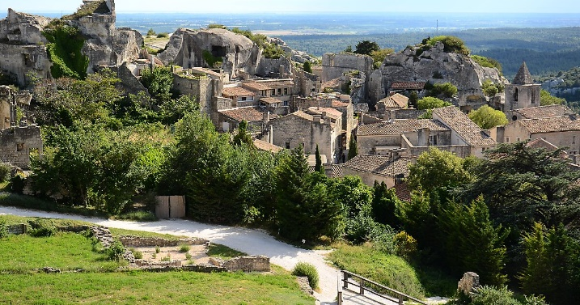

Les Baux de Provence The summit of Mont Ventoux

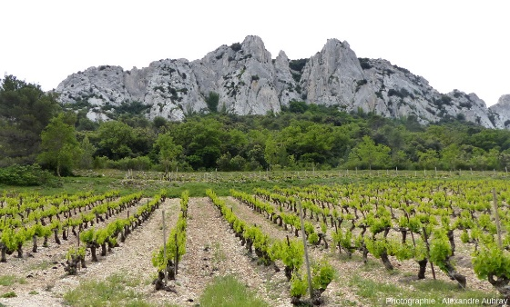 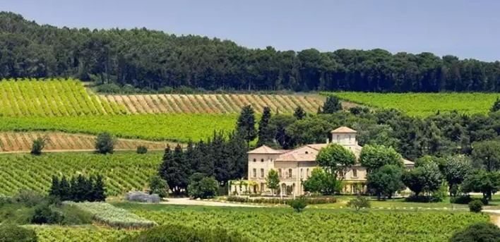

Les Dentelles de Montmirail Les domaines de Châteauneuf-du-Pape

The tour will end in Bagnols-sur-Cèze after which participants can either drive home or arrange for a transport company (e.g., EM Rogers) to transport their car to the UK or another destination on the Continent of Europe. Discussions will take place with EM Rogers to seek to clarify a bulk rate for transport of cars from Provence to the UK (as for the Habsburg Tour in 2022). Further details will be provided in due course. But the Club will not take responsibility for these transport arrangements. Should members wish to transport their car to the start or from the finish, they should notify the organiser when booking. Note however that tow-cars & trailers are not allowed to follow the route and no parking for them will be provided at intermediate hotels.

**Champagne to Provence**

**Friday 7th June to Tuesday 18th June 2024**

Please e-mail [johnstuttard@btinternet.com](mailto:johnstuttard@btinternet.com) and scan/send this form to Sir John Stuttard, Layton House, 23 Layton Lane, Shaftesbury SP7 8EY, with copy to the club’s Treasurer, Philip Hall: [pah.rr@btinternet.com](mailto:pah.rr@btinternet.com) and also to Maurice Whitaker: [whitaker.maurice@gmail.com](mailto:whitaker.maurice@gmail.com)

I would like to join this tour of 11 nights starting on Friday 7th June 2024 and finishing on Tuesday 18th June 2024. The price of the tour will be from £7,000 per couple depending on the category of the room chosen. The prices include a reception and wine with dinner. There will also be wine tastings. The prices are based on current exchange rates (£1 = €1.13) and may have to be adjusted if rates change adversely. Hotels in France are now demanding an upfront payment of 50% when rooms are confirmed. Sadly, the club has to match this and therefore a deposit of 50% of the tour price chosen is required now to secure a place on this tour. Note: deposits are non-refundable in the event of cancellation unless a substitute is found, or hotel credits obtained.

Full names of driver and passengers: …………………….……………………………………………………..……..

Address: ………………………………………………………………………………………..………………………

E-mail address: ……………………………………………………………………………………......

Number of mobile phone/(s) on tour……………….……………………………………………………

Dietary requirements, if any................................................................................................................

Please indicate your order of preference (eg 1,2,3) for your preferred category of room in the boxes below and send a deposit of 50% of your first choice. **Members are encouraged to pay in euros rather than pounds to guarantee the price:**

Classic (£7,100 or €8,023) Superior/Privilege (£7,700 or €8,701)

Deluxe (£8,000 or €9,040) Premium/Junior Suite (£9,000 or €10,170)

Senior Suite (£10,000 or €11,300)

The size, aspect and quality of each category increase with the price shown. There are few ‘Classic’ rooms.

The Junior Suites have separate lounge areas but there are also very few in each hotel.

Type of bed: Double or twin …………………………….

Car: Model............................................... Chassis No................ Reg No................... Year................

Body style/type.........................................................Colour(s)......................................

As a participant in this event and in consideration of the right and privilege to enter and participate in this event and intending to be legally bound, I agree to release The 20-Ghost Club Limited and all committee members and its representatives from any and all liability and injuries, damage or loss or consequential loss arising from my entry and participation in the event. I also agree that information about the participating car, the names of the driver and passengers, including photographs taken during the event and tour, may be published in the Club’s journal, *News & Record*, unless I inform the Editor by e-mail that I do not wish such information and/or photographs to appear. I confirm that I will have public liability insurance cover in place for France should I be accepted for this tour/event. I further confirm that I have read and understand the Club’s rules relating to tours (deposits and cancellations) contained in paragraphs 10 to 13 of the Club Rules contained in the Members’ section of the Club’s website under Statutory & Legal.

Signed…………………………………….. Dated ……..................................................

|  |  |
| --- | --- |
| For Sterling:  Bank – Lloyds;  Sort code: 30-96-35  Branch: CARFAX OXFORD  BIC: LOYDGB21023  IBAN: GB69 LOYD 3096 3500 0668 03  Account name: The 20-Ghost Club Limited  Account no: 00066803 | For Euros:  Bank - C Hoare & Co  37 Fleet Street, London EC4P 4D  Account Name: The 20-Ghost Club Ltd  Sort Code: 15-99-00  Account No: 27487380  IBAN: GB88 HOAB 1599 0027 4873 80  BIC: HOABGB2L |

Note: The hotels and itinerary shown above are based on current plans. Once applications and deposits have been received, these arrangements will be progressed and confirmed although there may be unavoidable changes to hotels and other plans.