

**The Dorset Tour**

From Sunday 1st September to Thursday 5th September 2024

We will be based at Wareham for 4 nights from Sunday 1st September 2024. Wareham is one of the few remaining Saxon walled towns, where the rivers Frome and Piddle meet, and is situated on the edge of the Isle of Purbeck. The main hotel will be The Priory, with additional rooms at The Bear a short walk from The Priory where dinner will be served each evening for the entire group. The Priory is a picturesque, independent hotel situated on the banks of the River Frome.

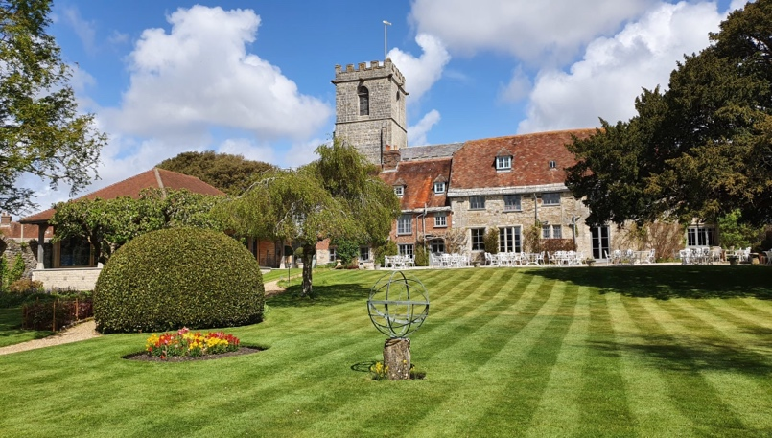 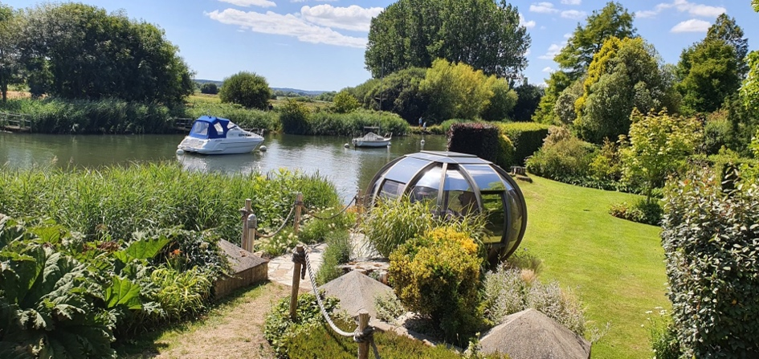

We plan to begin our Tour with a visit (possibly on the Sunday afternoon) to Tyneham Village. Tyneham is a ghost or lost village abandoned in 1943 due to the nearby tank firing range and is now only open for short times of the year.

On Monday, we plan to drive along the Jurassic Coast, a World Heritage Site, to West Bay. This drive will be along one of the most scenic routes in the UK.

Another day’s tour is planned passing through several of Dorset’s charming villages, reaching the highest point in Dorset, and by the Cerne Giant with the opportunity to visit Mapperton House and Hardy’s Cottage.

A visit to Stourhead via Badbury Rings and the Zig-Zag Hill, near Shaftesbury, is also planned on another day.

Costs will not be known until December 2023/January 2024 but are likely to around £2,200 per couple for The Priory and £1,850 per couple for The Bear.

Initial interest is being sought by email to Steve Wilks at [rslwilks@gmail.com](mailto:rslwilks@gmail.com).

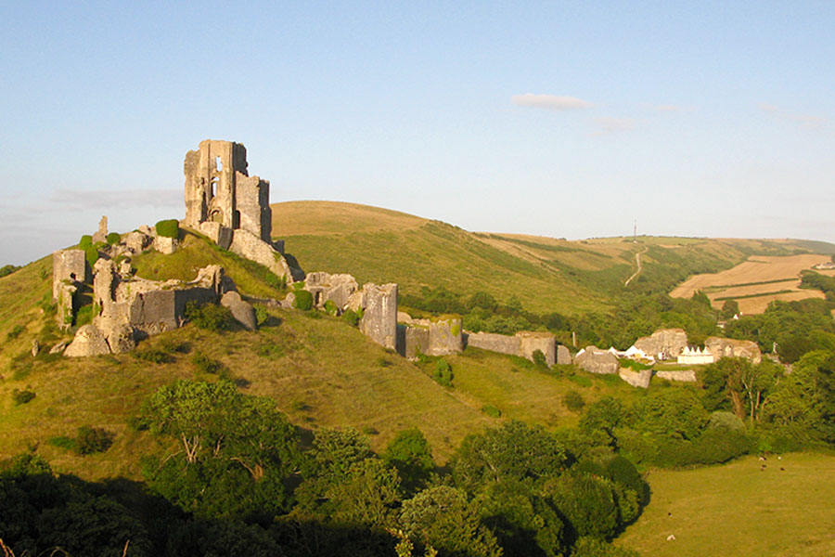

Corfe Castle

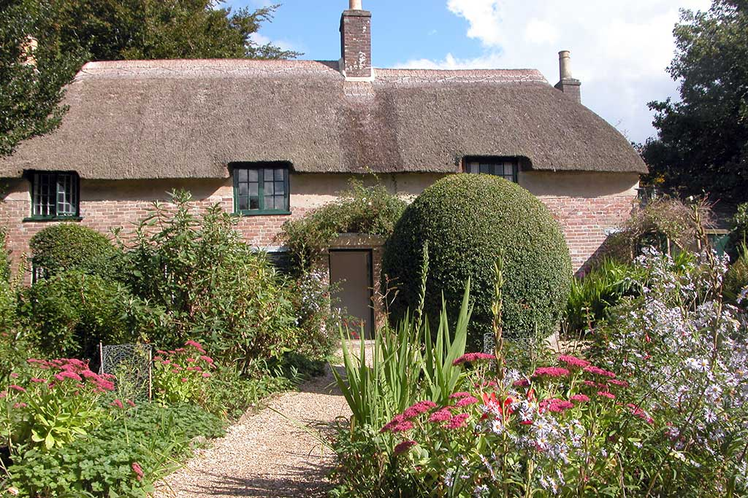

Hardy’s Cottage