

# THE 20-GHOST CLUB LIMITED

## Registered Number 5224632

The Oldest Rolls-Royce Car Club in the World

# Website: [www.20-ghost.org](http://www.20-Ghost.org)

In the year of the King’s Coronation our usual Autumn Lunch is being re-branded as The Autumn Tour. Starting on Sunday 24th September, we shall be based at The Hare & Hounds, Bath Rd, Westonbirt, Tetbury GL8 8QL [Phone](https://www.google.com/search?client=firefox-b-d&sxsrf=AJOqlzV9sS0dBPNL3zJxKkdhTAYc-3Fe3Q:1679016439106&q=the+hare+and+hounds+hotel+phone&ludocid=10808690102181943952&sa=X&ved=2ahUKEwiJ5bLT5-H9AhUTP8AKHT2LDzkQ6BN6BAhvEAI): [01666 881000](https://www.google.com/search?client=firefox-b-d&q=hare+and+hounds+tetbury) We have reserved all fifteen rooms (the final five rooms will be located in another local hotel still to be chosen). The plan is to meet at the Hare and Hounds at any convenient time after noon on the Sunday to settle in before our evening dinner.

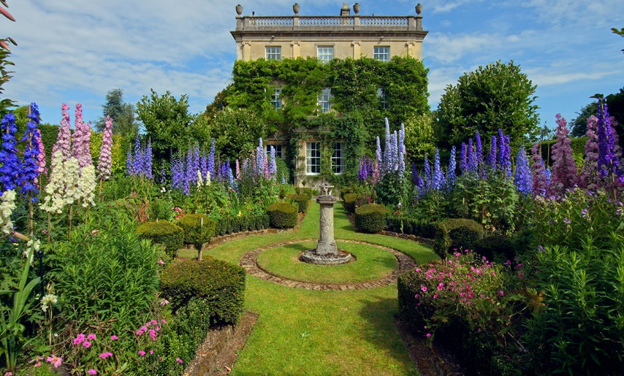On Monday 25th September we are scheduled for a “Private Guided Walking Tour” of King Charles, Gardens at Highgrove Tetbury   
GL8 0AY, where we have been allocated forty places.

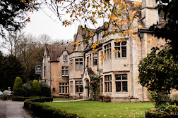We must depart the hotel punctually to drive the 1½ miles to Highgrove as it is essential we arrive on time. Drinks and toilet facilities are not available prior to the tour but afterwards we will have the opportunity to use the Orchard Room, where tea, coffee and snacks will be available at own expense.

On Tuesday 26th we are planning a private tour of another stately home, the details of which will be released once we have formalised our visit. We expect to have a Black Tie Gala Dinner on our final evening.

The Cost of the tour is £1185 per couple,** for the three night stay 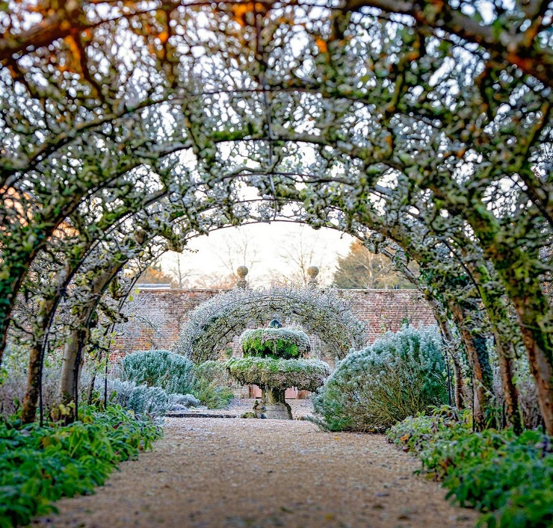including dinner bed & breakfast in a superior double bedroom. This is a popular tourist attraction and the club will have to put down a 25% deposit on booking & pay the full cost six weeks prior to the event. **A small surcharge will be added for a prosecco reception, canapes & wines covering the three nights.

I/We would like to book our places to attend the Autumn Tour at Highgrove as well as the additional visits yet to be finalised.

Name.............................................................

Number of places required………………..….

Address: ....................................................................................….Post code……………

Telephone no/s …..................................Email (in capitals please) ...............................................

Please return your entry preferably ASAP to :- [ashley@aacarmichael.co.uk](mailto:ashley@aacarmichael.co.uk)

If you, or a member of your party have any Dietary issues, please advise now so that arrangements can be pre-made.

Car: Model ……..………… Chassis No ......................... Reg No ….……..…..……Year .............................

Body style ................................... Coachbuilder ................................. Colour .............................................

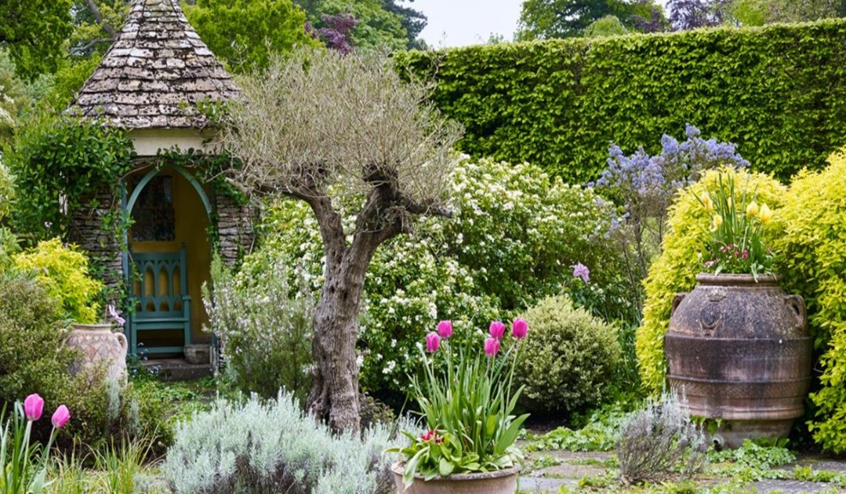As a participant in this event and in consideration of the right and privilege to enter and participate in this event and intending to be legally bound, I agree to release The 20-Ghost Club Limited and all committee members and its representatives from any and all liability and injuries, damage or loss or consequential loss arising from my entry and participation in the event. I also agree that information about the participating car, the names of the driver and passengers, including photographs taken during the event and tour, may be published in the Club’s journal, *News & Record*, unless I inform the Editor by e-mail that I do not wish such information and/or photographs to appear. I confirm that I will have public liability insurance cover in place for this trip should I be accepted for this tour/event.

Signed...............................................

Date.............................................

I will make a BACS pyt to the Club’s account with Lloyds Carfax Oxford: s/code 30-96-35, a/c no 00066803;   
IBAN:GB69 LOYD 3096 3500 0668;   
BIC: LOYDGB21023.

Please email confirmation of payment to

Philip Hall: pah.rr@btinternet.com