A Weekend in Dorset
Friday 27 to Sunday 29 or Monday 30 April 2012

The Spring lunch will be held, as usual, at the Macphersons, Armsworth Park House, Old Alresford, Hampshire SO24 9RH on Friday 27 April 2012. The Dorset Weekend tour will take place immediately thereafter.

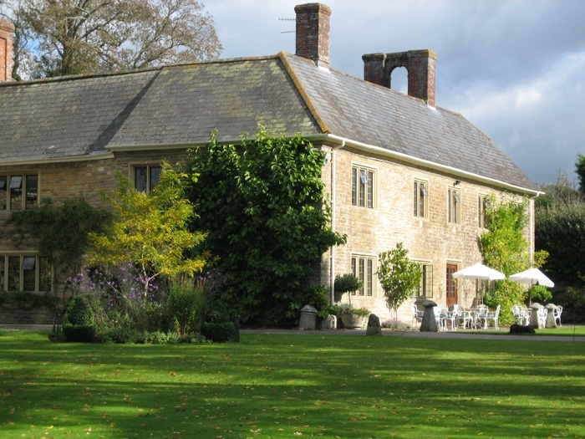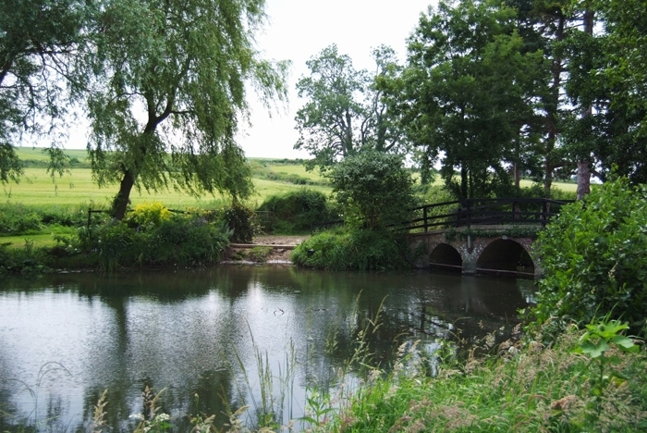
Plumber Manor Hotel, Sturminster Newton Plumber Manor Gardens

Based at Plumber Manor, a delightful country hotel near Sturminster Newton, the weekend will kick off on Friday evening with dinner at the hotel and will end on Sunday after a finger buffet lunch at Bovington Tank Museum. There is an optional stay of a third night (Sunday) for visits on the Monday.

On Saturday, there will be a tour of Dorset’s wonderfully rural countryside, loved by Thomas Hardy. The journey will embrace Bulbarrow Hill, through the attractive Piddle Valley to Tolpuddle, the village which gave its name to the Martyrs. There will be a visit to Athelhampton, a stunning 15th century manor house. The journey will then skirt Dorchester and take cars down to Abbotsbury, site of the famous Swannery, and then along the Jurassic Coast to West Bay, Bridport for a fish lunch.

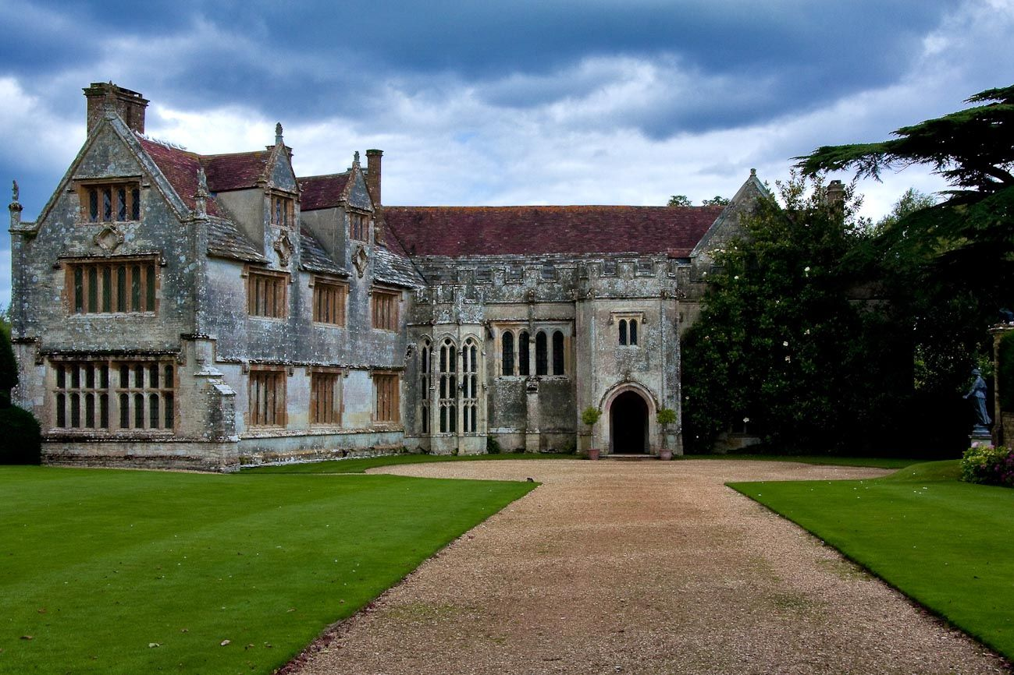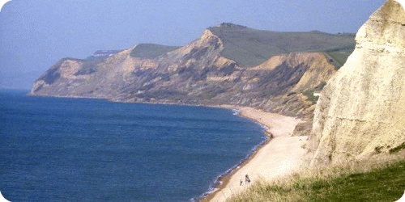
Athelhampton West Bay, Jurassic Coast

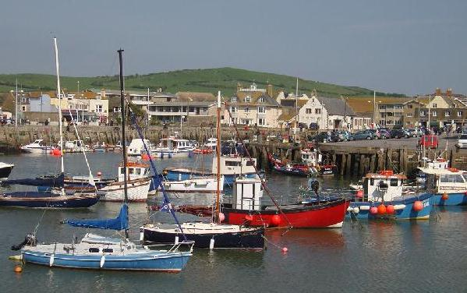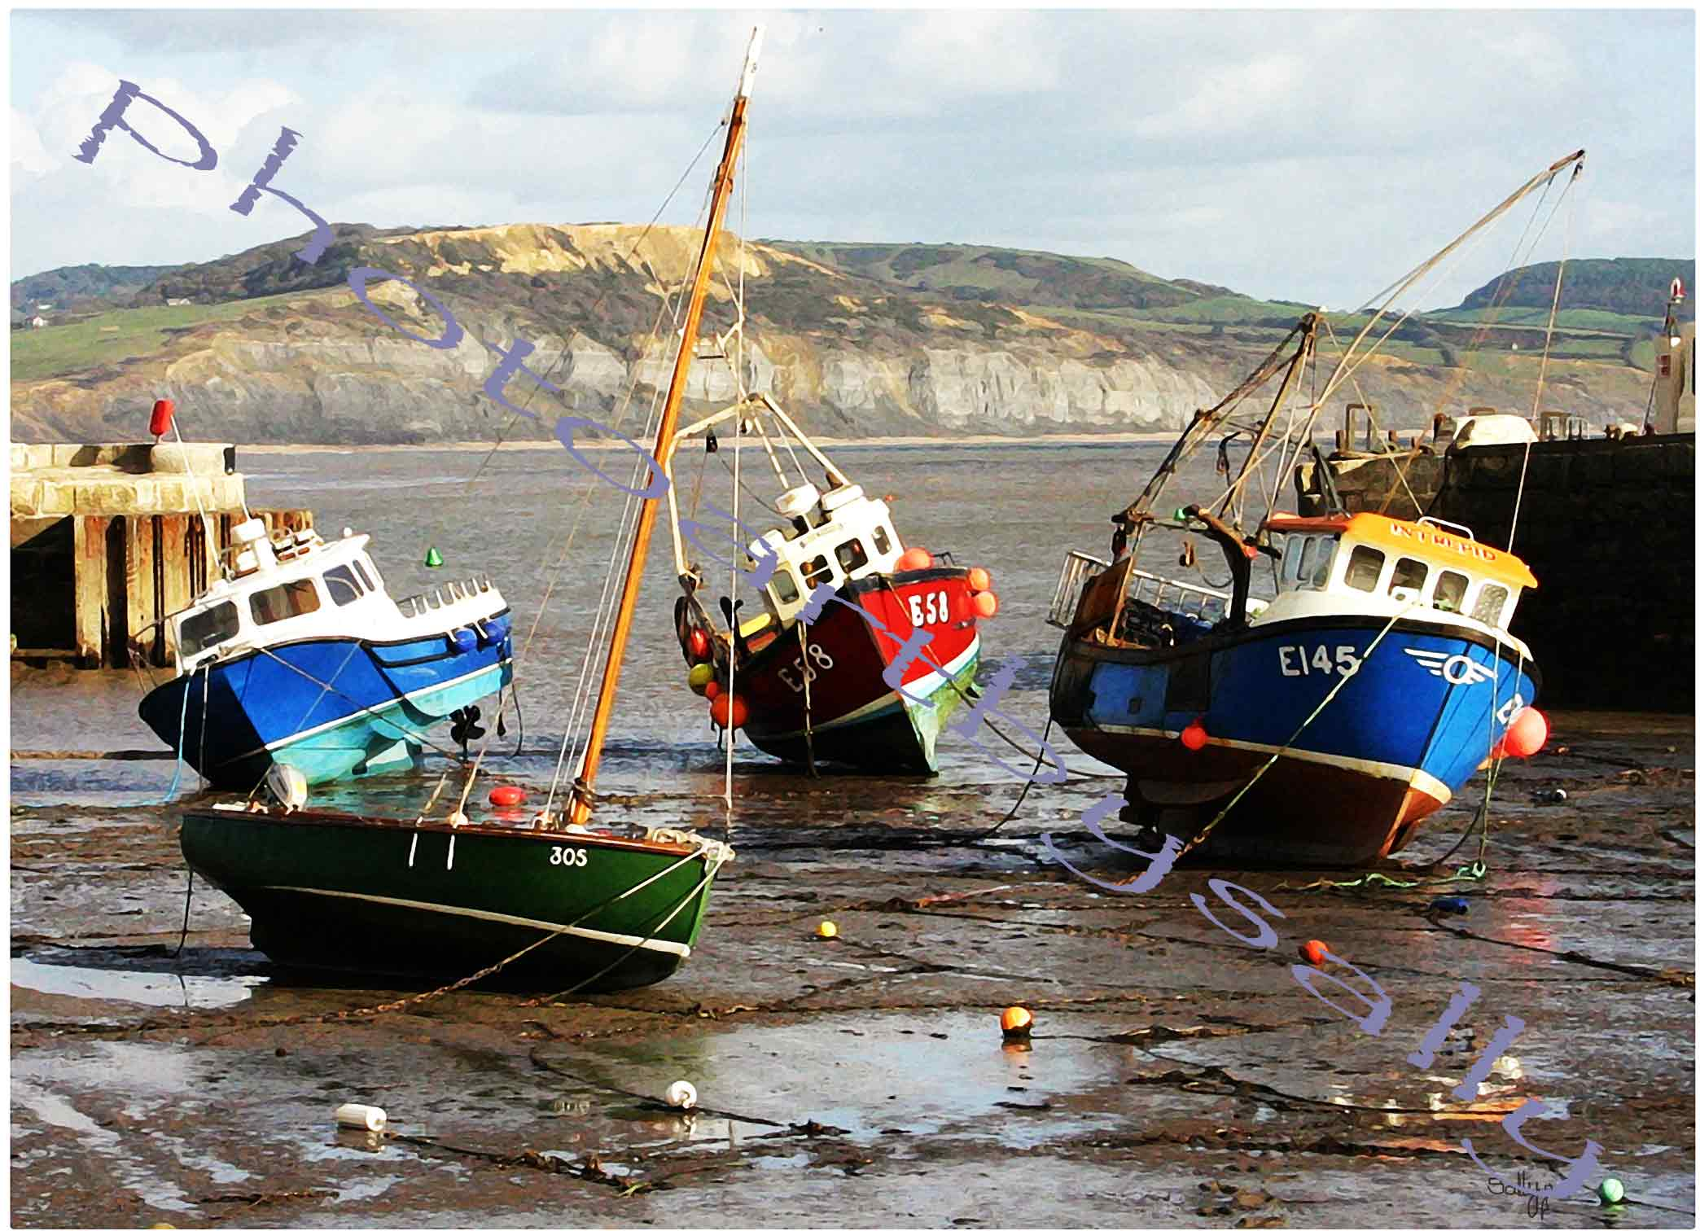
West Bay, Bridport Lyme Regis

The return journey will take members’ cars slightly further west to Lyme Regis and then back through West Dorset, near the iron age settlement on Eggardon Hill, through Poundbury (the Prince of Wales’ model village on the western edge of Dorchester) and the ancient village of Cerne Abbas, the home of the Cerne Giant, then back to Plumber Manor at Sturminster Newton for dinner.

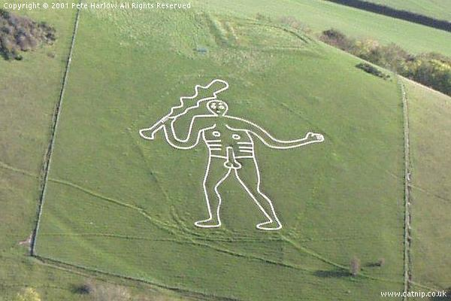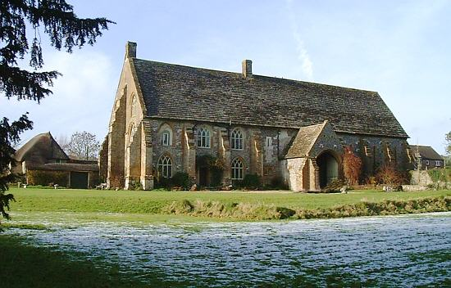
Cerne Giant 14th century tithe barn, Cerne Abbas

On Sunday members will drive through Shaftesbury, up Zig Zag Hill to the top of Cranborne Chase, before visiting Kingston Lacy, a stunning National Trust property near Blandford. This will be followed by a visit to the Tank Museum at Bovington (including its 1920 Armoured Rolls-Royce) and lunch.

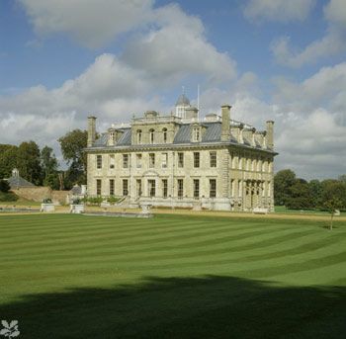
Kingston Lacy Bovington’s 1920 Silver Ghost Armoured Car

For those that wish to stay an additional night (on Sunday) with dinner at Plumber Manor, there will be the opportunity of visiting other attractive sights on Monday, including Shaftesbury and Stourhead.

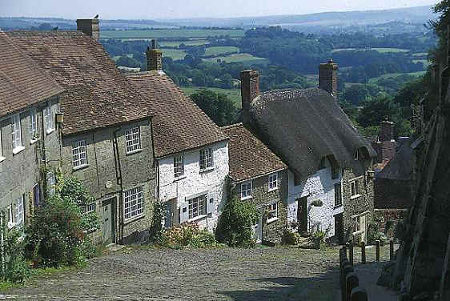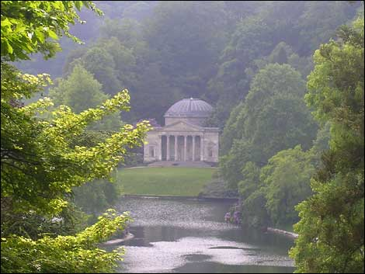
Gold Hill, Shaftesbury Stourhead

The cost of the weekend (Friday and Saturday night at Plumber Manor, including dinners, but not wine, + finger buffet lunch at Bovington Tank Museum on Sunday) will be £520 per couple.

Lunch at the stunning Riverside Restaurant at West Bay on Saturday will be charged separately at £80 per couple, excluding wine.

To stay an extra night (on the Sunday) at Plumber Manor (Dinner, Bed & Breakfast), the additional cost will be £250 per couple.

To secure a place on this event, please send a cheque for £400 per couple, made out to “20-Ghost Club Limited”, to Brian, together with the attached completed form.

To: Brian Palmer, Seeklands, Ratby Meadow Lane, Enderby, Leicestershire LE19 2BN

Names………………………………………………………………………………………………

Address…………………………………………………………………………………………..…

……………………………………………………………………………………………………...

E-mail…………………………………….…… Phone……………..….………

Please include us on the Dorset weekend at a cost of £520 per couple for two nights.

We would also like:
- Lunch on Saturday at The Riverside Restaurant, West Bay* ___
- An additional night at Plumber Manor on Sunday* ___
* tick or delete as applicable.

I enclose a (non-refundable) deposit of £400 per couple made out to “20-Ghost Club Limited”.
If you wish to pay in euros or dollars, please advise Brian Palmer and he will arrange for the Treasurer to send you details of our bank account.

Model………………………..Chassis No……………..Reg No……………….Colour……………..

Year “Off test”………………..Body style……..………………….Coachbuilder…………………….

As a participant in the 20-Ghost Club Weekend in Dorset and in consideration of the right and privilege to enter and participate in this event and intending to be legally bound, I agree to release the 20-Ghost Club and all committee members and its representatives from any and all liability and injuries, damage or loss or consequential loss arising from my entry and participation in the event

Signed…………………………………………………………………..Date……………………

The 20-Ghost Club Limited Registered Number 5224632

