Mid-week in West Devonshire
Tuesday 22 April to Friday 25 April 2014

The Midweek Spring Tour 2014 to Devonshire will be based at the beautiful Jacobean Lewtrenchard Manor Hotel, (www.lewtrenchard.co.uk) near Okehampton, Devonshire EX20 4PN arriving Tuesday 22nd and leaving after breakfast on Friday 25th April.

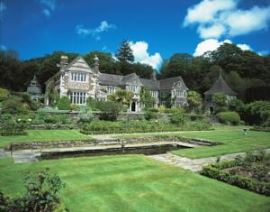 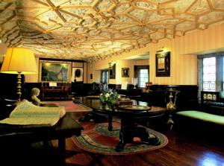 Lewtrenchard Manor Hotel The Long Gallery

Magnificently set in a secluded valley beneath the wild tors of Dartmoor looking over its parkland, Lewtrenchard Manor is a luxurious country house virtually untouched by time. Mentioned in the Domeday Book, this family-owned Jacobean manor that now stands in these impressive grounds dates from the early 1600s. The manor has been sympathetically restored and enjoys accolades for its high quality cuisine. It has portrait lined walls, antique filled rooms and blazing log fires; all ingredients to make for a relaxing stay.

Arrive in your own time on Tuesday to settle in to your room and perhaps enjoy a proper Devonian cream tea before dinner is served in our private dining room. We will then enjoy two full days touring around Devonshire and venturing into Cornwall, returning to the hotel for dinner each evening.

Trips will be plotted exploring Dartmoor and also visiting a variety of Country Houses in both North Devon and Cornwall, including some owned by the National Trust, so those of you who are members do not forget your membership cards!

The cost of the tour will be £645 per couple per night for the three nights stay, to include breakfast and dinner. Please note: Drinks and sundries are NOT included in the price; these will be the
responsibility of those ordering them.

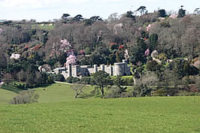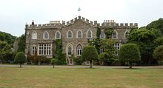
Caerhays Castle and world renowned Camellia
Gardens, Cornwall Hartland Abbey North Devonshire

THE HOTEL ONLY HAS 14 ROOMS, SO PLEASE RETURN YOUR BOOKING FORM AND DEPOSIT AS SOON AS POSSIBLE TO BE SURE OF SECURING YOUR PLACE.

Please send a deposit cheque for £215 per couple, made out to “20-Ghost Club Limited”, to Graham Tyson together with the completed booking form below.

To: Graham Tyson, The Old Vicarage, St Minver, Nr Wadebridge, Cornwall PL27 6QH

Names………………………………………………………………………………………………

Address…………………………………………………………………………………………..…

E-mail…………………………………….…… Phone……………………..……Mobile………………………….……….

Please include us on the Midweek West Devon Tour at a cost of: £645 per couple for three nights
I enclose a (non-refundable) deposit of £215 per couple made out to “20-Ghost Club Limited”.

Model………………………….…..Chassis No……………..Reg No………….……….Colour…………………………

Year “Off test”………………..Body style……..…….……………….Coachbuilder…………………..…………..…….

As a participant in the 20-Ghost Club Mid Week Tour in West Devonshire and in consideration of the right and privilege to enter and participate in this event and intending to be legally bound, I agree to release the 20-Ghost Club and all committee members and its representatives from any and all liability and injuries, damage or loss or consequential loss arising from my entry and participation in the event

Signed………………………………………………………………… Dated..........................................

