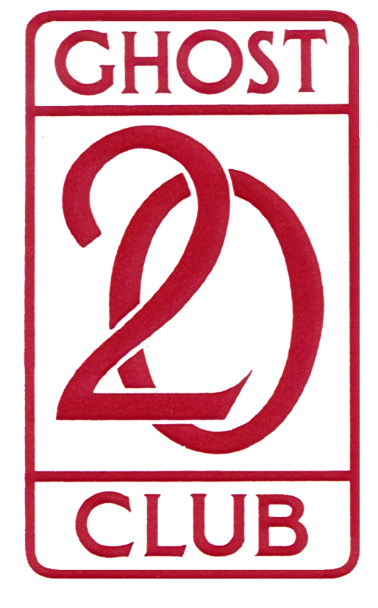

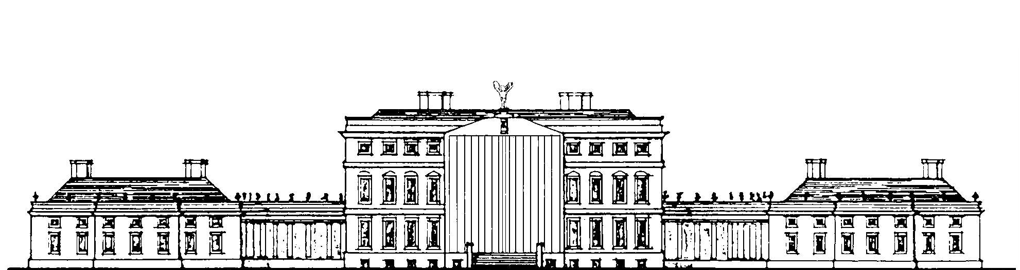

TOUR OF DERBYSHIRE with the IRISH GEORGIAN SOCIETY

MONDAY 9th to FRIDAY 13th MAY 2022

As 20-Ghosters will be aware, the first Country House tour with the Irish Georgian Society was to Oxfordshire in 1978, and these tours are now a firm fixture in the annual calendar of both societies. This year’s tour will be in Derbyshire, last visited together 39 years ago (1983!) and all agreed that it is certainly time for a return visit. This is most welcome, it being three years since the last tour, to North West Ireland in 2019.

Derbyshire is known for being the county with some of the greatest houses in the land. As always, a number of the houses we will be visiting are still in private hands – many of them for centuries. The itinerary is not finalised at the time of writing this, so things are still somewhat fluid. So far we have concentrated on lining up the less well known houses and the tour is expected to include Melbourne Hall, Staunton Harold Hall, Tissington Hall, Renishaw Hall, Locko Park, Radbourne Hall and Wootton Hall. Others are in the pipeline, and members should remember that the itinerary is subject to change as details are confirmed. At present a visit to Charsworth is not included in the tour, as it is expected that most of those coming on the trip will have visited the house and gardens in the past. Alternatively you might like to consider a visit either before or after the tour.

In view of the large number of houses to be visited – and the logistics involved – it has been decided to start the tour immediately after breakfast on Tuesday 10th May and to finish at the usual time of late afternoon on Friday 13th May. More precise details will be sent to all those booked on the tour when the arrangements and itinerary have been confirmed. As always, Irish Georgians will be asked to change cars every day and not keep to the same car throughout the tour.

The tour will be based at the Breadsall Priory Hotel, Moor Road, Morley, Derby DE7 6DL. The hotel is approx 5 miles north of Derby. To quote from the hotel’s website: “*Nowhere does the allure of history meet modern comforts more elegantly*”. We shall see!

The cost to 20-Ghosters will be £890.00 per person sharing and will include dinner, bed & breakfast for the nights of Monday 9th, Tuesday 10th, Wednesday 11th and Thursday 12th, lunch on Tuesday, Wednesday, Thursday & Friday, drinks at most meals, and house entrance fees. There are some single occupancy rooms at £1,010.00. There are also a small number of Superior double / twin rooms afor £1,990.00. If additional accommodation at the hotel is required on either side of the tour, individuals will need to make their own arrangements direct with the hotel.

If you would like to participate, please complete the attached application form and return it, with a cheque made out To **Irish Georgian Society London** and a SAE, to Jimmy Valentine, 16 Upper Astrop Road, KINGS SUTTON, Oxforshire OX17 3QL

The 20-Ghost Club Limited Registered Number 5224632



# THE 20-GHOST CLUB LIMITED

## Registered Number 5224632

The Oldest Rolls-Royce Car Club in the World

# Website: [www.20-ghost.org](http://www.20-Ghost.org)

TOUR OF DERBYSHIRE

with the Irish Georgian Society

MONDAY 9th to FRIDAY 13th MAY 2022

Return **AS SOON AS POSSIBLE** to Jimmy Valentine, 16 Upper Astrop Road, KINGS SUTTON, OX17 3QL, with a cheque for the appropriate amount [sorry, no electronic transfers] AND an SAE.

I/we would like a double / twin room for £1,780.00 for two CIRCLE AS REQUIRED,

£1,040.00 for single room occupancy.

£1,990.00 for a Superior Double room, double / twin – CIRCLE AS REQUIRED

I enclose a cheque for the appropriate amount, and a SAE if not on email.

Name/s…………………………………………………………………………………………………………………………………….

Address……………………………………………………………………………………………………………………………………..

……………………………………………………………… Postcode …………………............ Tel ………………………………

email address ………………………………………………………………………… [legibly AND in capitals please!]

Dietary requirements, if any ……………………………………………………………………………………………….………

Car: Model ………………………… Chassis ……………………. Reg ………………............Year ..............................

Coachbuilder………………….…………………. Body style ………..………………… Colour………………………………

Number of comfortable [!] seats I/we can offer to Irish Georgians ……………………………………

Submission of this form is my confirmation that my 2022 membership of the 20-Ghost Club has been paid and that my vehicle is fully insured for the period of the tour.

*NOTE: As a participant in the 20-Ghost Club Tour of Derbyshire with and organised by the Irish Georgian Society, and in consideration of the right and privilege to enter and participate in this event and intending to be legally bound, I agree to release the 20-Ghost Club and all committee members and its representatives from any and all liability and injuries, damage or loss or consequential loss arising from my entry and participation in the event*

*Signed …………………………………………………………………………………. Date ………………………………………………..*

The 20-Ghost Club Limited Registered Number 5224632